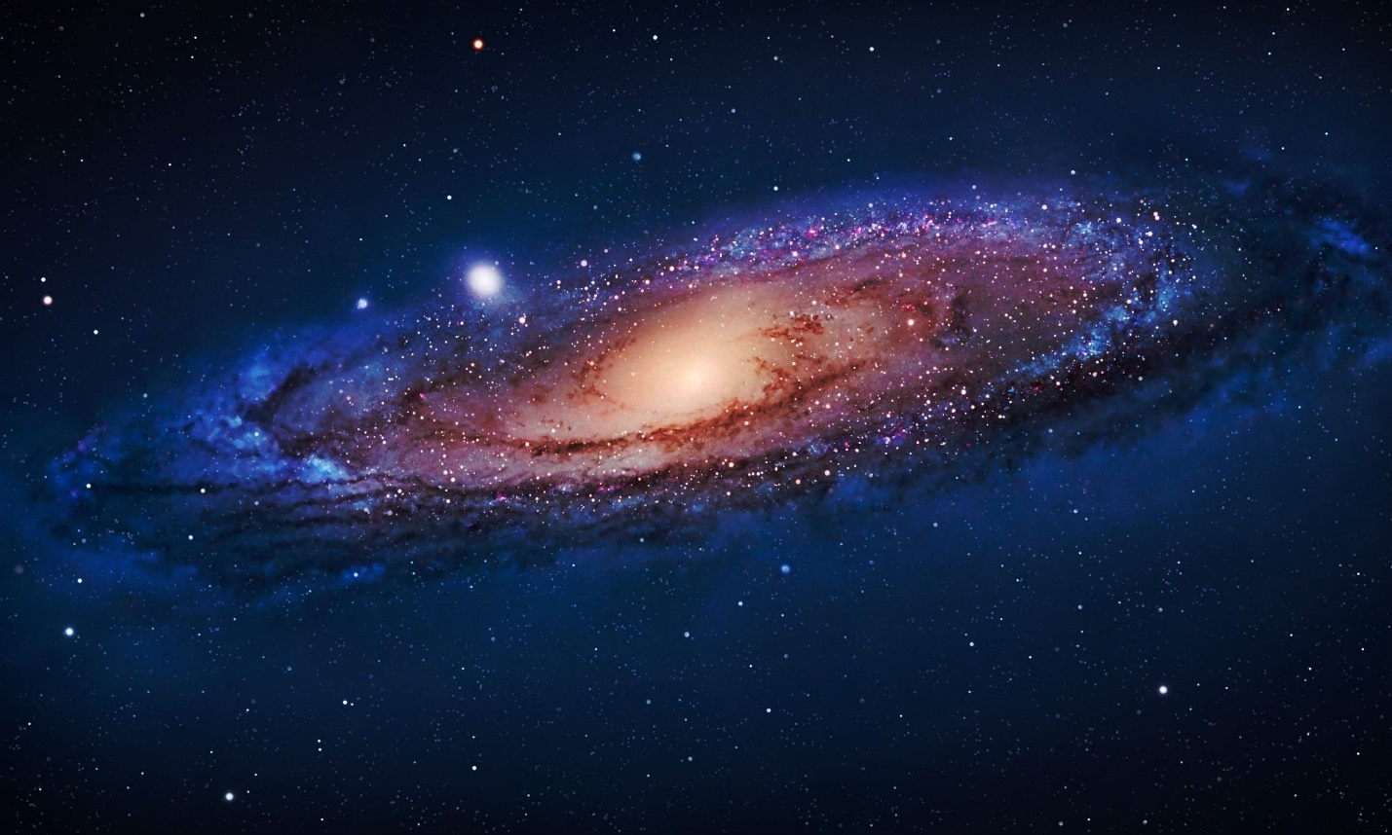

FROM GRAVITONS TO GALAXIES
(A New View of the Universe)

Gregg L. Wilson

Dedicated to Astronomer
Tom Van Flandern

Table of Contents
Introduction
Cosmology
Physics
Gravity
Light
The Atom
The Proton
Hydrogen
Deuterium
The Hydrogen Bomb
The Solar System
The Sun
Supernova
The Earth
Planetary Rings and Moons
Tritium
Helium-3
Helium-4
Lithium
Beryllium
Boron
Carbon
Nitrogen
Magnetism
Electricity
The Great Pyramid
Second and Third Pyramid at Giza
The Great Flood
Extraterrestrials
Formulation of Polydeuterium Rod
Rocket Engine
Energy Replacement
Summary

INTRODUCTION
This paper is written for the reasonably educated citizen on the street. A very basic knowledge of physics and chemistry is required but no more than that. Subjects are explained in a logical manner with many diagrams and pictures. Equations and calculations are kept to an absolute minimum.
There has been a mental deficiency among many persons who have endeavored in the fields of cosmology, astronomy, physics and chemistry. Actual observations and experimental results overrule theory, no matter how grand the theory is or how long it has been accepted as fact. The problem is that scientists accept new theories even when real data contradicts these theories.
The problem began with Isaac Newton’s Law of Universal Gravity. The equation of this law calculates the effect of gravity but not its cause. Newton even admitted that his law was incorrect. Yet this law is accepted as universal fact to this day. Einstein dared not dispute Newton’s law but attempted to create ideas in agreement with this law. This led to further theories that were in fact incorrect but should not be questioned because of the prominence of Einstein.
In 1887 Michelson and Morley carried out an experiment to determine the velocity of the Earth through what was presumed to be a light carrying medium. Their result was a velocity of 9 kilometers per second. It was assumed that this was random experimental error and it was concluded that a light carrying medium did not exist. This decision proceeded to blind scientists to one third of Reality. Later Michelson would retract this decision but to no avail.
Rutherford experimented with using alpha radiation to penetrate gold foil and concluded that the atom was basically empty with only a very, very tiny nucleus. Rutherford had already decided that the atom would be just like a miniature solar system and had his experiment “prove” that. When it was obvious that electrons would instantly collapse into the nucleus, Niels Bohr “saved the day” by decreeing that electrons had fixed orbits. No evidence for this but who cared?
Edwin Hubble, not daring to question Newton’s Law of Gravity, proceeded to declare that the Universe was expanding. That led to the Big Bang, a speculation without evidence or rational logic.
In current times scientists, operating at the sub atomic level, have invented a vast array of “fundamental” particles such as up quark, down quark, lepton, antiquark, muon, tau, gluon, slepton, squark, gluino and so on. Particle physics lists 200 sub atomic particles. They have properties of charm, color, mood, strangeness, flavor, up, down and on and on. Instead of Reality being simple at the fundamental level, it is a vast menagerie of entities.
The overall result is that we have made very little progress in advancing technology useful to humans. Most “progress” remains in the fantasy realm.
This paper goes back to the very start and proceeds to examine the laws of cosmology, physics and chemistry. The conclusions are very different from mainstream science. Hopefully, this will initiate a new line of thinking.

COSMOLOGY
We could start at the beginning except there was no beginning:
Existence exists.
If the reader is amused, bemused or confused by this First Axiom, then consider the opposite:
Existence does not exist.
If one adopts this as a first axiom, then he has initiated, stated, and terminated his entire natural philosophy.
So, we shall return to Existence exists. One would think that this statement would not be necessary, but apparently it is. There is no alternative. The term Universe stands for all of Existence. To propose something outside the Universe in terms of lineal dimensions is meaningless. To hypothesize something before or after the Universe is also nonsense. Spatial dimensions and the dimension of time are properties of the Universe. In other words, the Universe is infinite in size and eternal in time. The Universe does not have an age because it does not have a lifespan. There is no beginning or end to the Universe. To propose so is to violate the axiom: Existence exists. The Universe does not have to be created; it simply is.
To propose “parallel” or “alternate” or “multiple” universes is simply not understanding the definition of universe.
The above facts are highly relevant because many proposed physical laws and theories violate this axiom. A particular case in point is Newton’s Universal Law of Gravity. If the equation is assumed to represent the actual mechanism of gravity, then one concludes that either the Universe is expanding to nothingness or contracting to nothingness. Thus, a literal interpretation of the gravity equation contradicts the fact that Existence exists. It leads to the conclusion that a stable, unending Universe is impossible, i. e. Existence is impossible and it leads to the conclusion that someone or something has to have created the Universe. But then, what created that someone or something?
The Universe does not consist of a finite summation of all particulars, such as the summation of “all” galaxies. No such finite “total” sum exists. All assemblies, such as planets, star and galaxies have a finite lifespan. They do come into being and they do finally end. This brings up a fundamental issue, because an assembly cannot spring into being from nothing. The issue is the Law of Causality: Any effect has a preceding cause. That cause, in turn, has a preceding cause. One cannot go back to a “First Cause”.
We have the current “proof” by Hubble that the Universe is expanding. This conclusion is actually derived from Newton’s Universal Law of Gravity. Newton’s gravity equation – if interpreted literally – means that all entities of mass attract all other entities of mass. Given the known masses of stellar objects and their distance from one another, under a literal interpretation of Newton’s law of gravity, the Universe would collapse unless for some unknown reason, it was expanding. Einstein realized this and proposed an unknown and undetectable force which counteracted gravity and caused the Universe to expand. When Hubble found that light from distant galaxies was red shifted, his assumption was that their light was red shifted because of their receding velocity. In reverse, this then lead to the assumption of the Big Bang. However, there are three major problems with these conclusions:
- Newton’s law – as interpreted – is an attractive force. But this constitutes action from a distant, which is impossible.
- Light does not get a “free ride” across the Universe. It pays a price – an energy loss – to the gravitational flux (a gravitational flux will be defined later). Since the velocity of light is constant, the light loses frequency and is red shifted. Thus, there are alternate ways for light to be red shifted rather than only by the receding velocity of galaxies.
- A Big Bang represents something coming from nothing. Again, impossible – no magic.
Humans apparently have a subconscious need for entities to have a beginning, a lifespan and a death. But Existence is not an entity. A proposed Big Bang abandons science and becomes religion.
There are observational results, which contradict the idea of a Big Bang in terms of geometry. A cataloging of galaxy positions has indicated that at the largest observable scale, there are great walls of galaxies separated by great voids. The walls appear to be about 16 million light years thick with no apparent limit to width and height. They are separated by great voids such that the walls are about 420 million light years apart. Our solar system exists within one wall. Six walls are observed to the approximate North and six walls to the approximate South. No further distance can be observed because of the optical limitations of telescopes. This is an impossibly huge wave pattern, not an expanding, homogeneous sphere of a Big Bang. The force of gravity does not explain this wave pattern.

PHYSICS
In mathematics, one can create any kind of prediction one can imagine. However, physics requires objectivity and non- contradiction. Actual data overrules theory. If a person can only “explain” his physical theory with an equation, then he does not actually understand the how and why of the phenomena. Equations allow the numerical calculation of a proposed result. The equation does not validate the result.
The most important paper ever written for physics is “Physics Has Its Principles” by astronomer Tom Van Flandern, Metaresearch, 2002. No other paper takes second place. It isn’t even a contest. I will paraphrase the principles stated by Van Flandern:
- Every effect must have an antecedent, proximate cause. Any effect must have a “means” to happen: the cause. An effect without cause is magic and cannot occur in Reality.
- There can be no reversal of time. An effect cannot precede its cause. That would be a contradiction. Therefore “time travel” is not possible. However popular in fiction, it cannot happen.
- There can be no true action at a distance. There has to be physical contact between a cause and an effect. In effect, there must be some kind of collision. The colliding particles may not be visible but they must exist. For instance, for the Sun to gravitationally effect the Earth, some “agent” must travel from the Sun to the Earth. This issue will be described in detail later.
- No creation ex nihilo. That is: Something cannot come into being out of nothing. There has to be cause.
- No demise ad nihilo. Something cannot become nothing. An assembly of fundamental parts can of course fall apart but the fundamental particles cannot simply cease to exist.
- The finite cannot become infinite. This is the psychological problem that most persons have about the Universe. No matter how large, a finite tabulation of entities cannot sum up the Universe. In particular, a property cannot become infinite, such as the Universe collapsing to a singularity of infinite density.
- Material entities cannot occupy the same space at the same time. For instance two nuclei cannot occupy the same space at the same time.

In slight disagreement with Tom Van Flandern, there are only four dimensions: three space dimensions and one time dimension. Dimensions are not entities but properties of Existence. Because they are not entities, they cannot be distorted, curved, changed by any entity or force. The proposal of additional dimensions by cosmologists or mathematicians is not real.
This brings us to the subject of fundamental particles:
A fundamental particle is precisely that. It is indivisible. It is not made up of lesser particles. In the same sense that Existence exists, a fundamental particle simply exists. It does not have a lifespan because it does not have a beginning or end. A particle, such as a proton does not have an age. Let’s consider properties of a fundamental particle:
- It has a size, which does not change.
- It has a geometric shape, which is permanent.
- It has a permanent mass, which means there is resistance to being moved unless a force is applied to it.
- It may or may not have an intrinsic velocity.
- A force or energy does not emanate from it. As will be seen, if such an action occurred, it would not be a fundamental particle.
- It is beyond dead; it was never alive. It does not “see” anything and cannot respond to action at a distance.
- Each fundamental particle is completely passive.
- Its only interaction with other particles is by direct collision.

A real world experiment was run in a deep underground iron mine in Minnesota to detect proton decay. A collection of 10^33 protons in a water chamber were observed for any decay over the span of 12 years. No such decay was detected. Thus, even if a proton has a half-life, that half-life has to be 10^34 years at a minimum. This time span exceeds the “lifespan” of all macroscopic entities in the Universe – such as great walls of galaxies. Therefore, for all realistic purposes, the proton is a fundamental particle which is eternal. It does not have an age.
If fundamental particles were popping into and out of existence, then constructs made from these particles would not retain their identity and properties. However, we observe entities that are millions of years old – with their identity preserved.
Because conventional physics has proposed numerous fundamental particles, it is appropriate to introduce Occam’s Razor. This principle states that the simplest hypothesis that adequately explains and predicts the phenomena is very likely the correct analysis. But no simpler. As one goes down in detail toward what would be fundamental particles, the basic population of fundamental particles should decrease to the minimum necessary number for explaining the nature of Existence. If the theory predicts an increasing number of fundamental particles, then it is in all likelihood wrong.
An axiom of Daimler Benz is that form follows function. That is, if you properly select materials in a correct geometry, then the vehicle should operate reliably. Basically, if you have arranged fundamental particles into correct entities, the vehicle should run.
However, the fundamental particles “come first”. They are permanent and eternal as is Existence. Consequently, we have the opposite of the Daimler Benz axiom: the geometry of the fundamental particles determines all constructs and their behavior. Function follows form. Geometry is, in fact, the bedrock of chemistry. Therefore, chemistry should be properly viewed as a subset of physics.

GRAVITY
The force of gravity has remained a mystery in mainstream science for centuries. Isaac Newton formulated his theory of universal gravity in 1689. However, his theory explained the effect of gravity, not the cause. He understood that the mathematical description of the theory strongly implied that this “force” was attractive. Newton, himself, openly declared that his theory was incorrect.
I now quote him: “That one body may act upon another at a distance through a vacuum, without mediation of anything else, by and through which their action and force may be conveyed from one to the other, is to me so great an absurdity, that I believe no man who has in philosophical matters a competent faculty of thinking, can ever fall into it.”
In simpler words, for you and me: no action at a distance; therefore the concept of an attractive force is completely invalid. An answer to his problem is as follows:
A kinetic theory of gravity was originally proposed by Nicolas Fatio de Duillier in 1690 and developed later by Georges-Louis Le Sage in 1748. The theory proposed a mechanical explanation for Newton's gravitational force in terms of streams of tiny unseen particles (which Le Sage called ultra-mundane corpuscles) impacting on all material objects from all directions. According to this model, any two material bodies partially shield each other from the impinging corpuscles, resulting in a net imbalance in the pressure exerted by the impacting corpuscles on the bodies, tends to drive the bodies together. This mechanical explanation for gravity never gained widespread acceptance, although it continued to be studied occasionally by physicists until the beginning of the twentieth century, by which time it was generally considered to be conclusively discredited. However, consensus by scientists does not determine Reality.

This theory has regained acceptance, largely through the efforts of Astronomer Tom Van Flandern. From about 1980 to 2000, through diligent observation, he has established the following:
- The size and mass of a “graviton” (the ultra-mundane corpuscle designated by Le Sage) is about 10 to 20 orders of magnitude smaller than that of a proton.
- Its average velocity is about 20 billion times faster than the speed of light.
- Its average distance of free travel, until it collides with another graviton, is about 3,000 light years.
Van Flandern’s specialty in astronomy was celestial mechanics – that is, gravity. By studying actual binary pulsars gravitational behavior, the speed of gravitons had to be at least 20 billion times the speed of light, or the binary system of the pulsars would fail and the stars would part and go their separate ways. Pulsars are extremely heavy, compact neutron stars which orbit each other at very high speed. Any detectable delay in the propagation of gravity would cause them to breakaway from one another. His careful examination of galaxy behavior indicated that the mean free path of a graviton would be about 3,000 light years. Beyond this distance the collisions and back scattering of gravitons would progressively diminish the effect of gravity between distance stars. This effect between stars is a blocking of gravitons traveling along the path of star to star. Thus, it appears as if they are attracting each other, but it simply a lack of repulsion by gravitons between them.
This means that a star, which substantially farther than 3,000 light years from our Sun would increasingly have less effect upon our Sun. However, a star 3,000 light years away from us would be affected by a star that is a further 3,000 light years away. There is a chain effect from star to star to star. The direct gravitational interaction between the galactic center and our Sun would be very small. But this chain effect would reach out to our Sun and indirectly cause it to be pushed towards the center of galaxy. There is a higher density of stars between the Sun and the galactic center than there are stars in the opposite, outward direction. Therefore, the Sun continues to orbit the galactic center. This gravitational push is weaker than that predicted by Newton, so outer stars in the galaxy move only at the velocity of inner stars. This causes the spiral arms of the galaxy to lag behind the rotational rate of the galactic center and they are bent backwards.
If Newton’s law of gravity is assumed, then mainstream science has to conclude that our galaxy is surrounded by dark, undetectable matter that is one hundred times more massive than that of the galaxy. There is no observational evidence that this unbelievably huge mass of dark matter exists.
Gravitational interaction between galaxies would be almost nonexistent because the common distance between them is millions of light years.
Even though gravitons travel at 20 billion times the speed of light, they do not emit or reflect electromagnetic waves. They are not heated and do not have a temperature. However, with an extremely tiny mass and super high velocity, one might characterize them as one part per million mass and 999,999 parts per million kinetic energy. There is, however, no such thing as pure energy. Just particles with mass and velocity. The fundamental particle of the light carrying medium, called the Elyson, causes what appears to be pure energy but that effect is simply the fundamental behavior of the light carrying medium particles.
An issue with Le Sage gravity is that if the collision of a graviton with, let’s say a proton, is elastic then the graviton retains its speed and no energy is transferred to the proton. Therefore, the proton would not be moved because it is hit from all angles by gravitons. If the graviton is absorbed by the proton, then the proton would presumably have a rise in temperature from the absorbed kinetic energy. If the graviton is deflected with a small loss in velocity, then some heating would occur and the proton would be moved – if the proton is asymmetric in shape. This means that the proton would not be a sphere but would have different response to a graviton impact, depending on where it hit the proton.
Astronomer Victor Slabinski derived a very rigorous, complex mathematical solution that would make the above small energy loss and slightly less recoil velocity work. The problem is, Reality is not aware of these mathematic results and does not obey them.
Astronomer Tom Van Flandern came extremely close the correct paradigm. He proposed that any kinetic energy absorbed by a mass would be re-radiated into space by electromagnetic waves. These waves would then lose energy to the graviton flux, thus re-establishing the original graviton velocity.
A gravitational field around a body of mass (the Earth, the Moon) is established by the fact that gravitons rebounding from the body have less velocity than gravitons coming down. That is, there is an overall net push downward. Therefore, some energy is being transferred to the body.
What was totally or partially ignored by the above astronomers was that the light carrying medium can condense to a liquid and vaporize back to being a gas (light is actually a momentum wave within a medium of particles just like a wave in the ocean). So, the proton itself does not gain energy, become heated and have a rise in temperature. The energy interaction is actually with the light carrying medium. If a graviton is slowed by the inelastic impact, a small transfer of energy to the overall body of mass is made. If the graviton is actually absorbed by the body of mass, a huge amount of energy is transferred to the body. This difference in energy absorption will be explained later.
A side question to the astronomers would be why the Sun is extremely hot and Pluto is extremely cold, if both are gaining the same small amount of kinetic energy from the gravitons? This difference will also be resolved later.
A final matter is gravitational shielding. Can matter become dense enough that the graviton flux cannot penetrate to the center of a body, like the Earth. If this is the case, then the total mass of the body is not measured by its gravitational mass. This means, with the gravitational push being limited to a finite strength, and the planet having more mass than gravity can interact with, it would be more difficult for gravity to move that body. If so, then the orbit of such a body will be more stable and resistant to change by gravity than we would calculate. This matter will be discussed later on.
If one accepts Newton’s law of gravity, then the gravitational force rises to infinity as the body’s mass rises to infinity. But no entity or property can actually become infinite.

LIGHT
Visible light is simply a limited band of the electromagnetic spectrum. The spectrum ranges from a wave length smaller than an atom (gamma rays), to a wave length of many kilometers as radio waves. Physicists have dealt with light waves for many centuries because they are obviously visible and their behavior can be readily observed.
It was accepted for about two centuries that there was an “aether” – a light carrying medium – until the Michelson Morley experiment of 1887. The experiment consisted of measuring the velocity of light in one direction and then in an orthogonal direction to see what was the speed of the Earth through the light carrying medium. They found little difference and the conclusion was that there was no light carrying medium. This then progressed to treating light as a particle – a photon.
Mainstream science insists that light is a particle and a wave. It cannot be both. It is either or. The axiom is proof positive, not proof negative.
The actual ether speed found by Michelson and Morley was about 8 km/sec at sea level. It was found to be 10 km/sec at Mt. Wilson, California. The final measurement was settled by the COBE satellite, which determined that the Earth was moving at 365 km/sec through the cosmic microwave background outside our galaxy– which is presumably everywhere and stationary. If an ether exists then this was the speed of the Earth through the universal ether, with the universal ether between galaxies being at rest.
Experiments with light are completely explained if light is a wave. But several of the experimental results cannot be explained if light is a particle. Since light has a wavelength and frequency, it must be a wave. A wave must be within a medium – as waves are in the ocean, with the medium being water molecules. Astronomer Tom Van Flandern labelled the light carrying medium as Elysium and the particles of the medium as Elysons. A wave in this medium is a momentum wave being passed forward by rearward elysons to forward elysons. The elysons themselves are not moving forward; the wave passes through them like sound in the atmosphere.
The Elysium is affected by the graviton flux. In outer space the temperature of the Elysium is about 2 degrees Kelvin, which is two degrees above absolute zero in temperature. So the universal impact of gravitons on elysons raises the temperature of the ether about two degrees Kelvin above absolute zero. However, these waves do not favor any particular direction; they are random.
Whether we select a proton or an atom or a dust particle or an asteroid or a planet and so on, they have one thing in common: they are in the way. They are obstacles to the graviton flux and to the ether.
We will take the case of Earth. The graviton flux pushes the ether up against the Earth. The ether becomes denser within our solar system and even denser the closer it is to the Earth’s surface. This has two major results:
- The motion of the Earth through the local ether degrades to about 8 km/sec at the surface of our planet (compared to the velocity of Earth to the distant ether between galaxies of 365 km/sec). The ether is literally piled up against the Earth. There is actually a viscosity within the local, dense ether next to the Earth the same as viscosity of water within a pipe – except that it is many orders of magnitude less than the viscosity of water.
- The velocity of light is reduced by the denser ether. We measure it at 300,000 km/sec at the Earth’s surface (even in a vacuum). It is unknown what the velocity of light is in thin ether out between galaxies, except that it is higher.
The most detailed and thorough description of this subject is given by Al McDowell in his book Uncommon Knowledge. I know of no other paper equal to his presentation.

THE ATOM
The first reference to the existence of an atom (an indivisible building block of larger entities) was made by the Greek Democritus in about 400 BC. Obviously no description but a conceptual step forward. No further progress would be made until John Dalton, in 1805, visualized the idea of an element, where any more division of that very small piece would cause the object to lose its identity and properties.
Benjamin Franklin experimented with lightning and declared electricity to be a fluid. He described a circuit position as being “positive” meaning that it had an excess of electrical fluid and another circuit position as being “negative” meaning it had a lack of electrical fluid. He did not identify any particles as having a positive or negative charge. During the 1800’s it became customary to use positive and negative in designing electrical circuits. Implicitly, the moving electricity became negative and a fixed position became positive.
In 1897, J. J. Thompson experimented and discovered an entity which moved through an electromagnetic field and was apparently smaller than an atom. He called it the electron and considered it to have a negative charge because of its response to an electromagnetic field in a vacuum. Although magnetism was obviously intimately associated with electricity, it was not known what magnetism is, and it is still not understood. He proposed a “plum pudding” model of an atom with distinct negative electrons buried in a “soup” of positively charged matter. It must be pointed out that charge, negative and positive, were human concepts and had no hard identification with reality.
His student, Ernest Rutherford, accepted the idea that a neutrally charged atom would have negative and positive charged entities. With his co-workers, he began to envision the atom as being like a miniature solar system. Experimentation with alpha particles being shot through an extremely thin gold foil resulted in most of the alpha particles going straight through and a very small number of alpha particles being ricocheted backward. With the alpha particle already being defined as a positively charged particle, it was assumed that the tiny minority of alpha particles being repelled had collided with the positively charged nucleus of a gold atom. When finally at rest, Rutherford discovered that the alpha particles were helium nuclei.
The general conclusion was made that the nucleus of an atom was incredibly small compared to the full volume of the atom. Therefore, the atom was basically empty. The nucleus was surrounded by a “cloud” of electrons. There is, however, a real problem with this conclusion:
The atomic weight of an alpha particle is four. The atomic weight of a gold nucleus is 197. The velocity of the alpha particle is 10% of the speed of light, which is 186,000 miles per second. So the alpha particle collides with a gold nucleus at 18,600 miles per second with the gold nucleus being at rest.
If the alpha particle simply collides with the gold nucleus and remains with the gold nucleus, they would both proceed forward at:
4 / 201 * 18,600 miles per second = 370 miles per second
If they were to ricochet, then the alpha particle would proceed backward at 9,300 miles per second and the gold atom would go forward at 189 miles per second. In either case, Rutherford should have observed the extremely thin gold foil being perforated by alpha particles. By his own definition, if an alpha particle is repelled, it must have hit only one gold nucleus.
The conclusion that the atom is empty was not proven. We will deal with this issue later on.
In general the “properties” of charge, negative and positive are human mental inventions and there is no hard evidence that they exist. Magnetism, which does have an effect on moving particles, is not electrical or charged nor does it give off heat and have a temperature.
There is more trouble with the Rutherford atom. He described the electrons as being a cloud around the nucleus. It was immediately obvious that, according to the existing physical laws made by men all electrons would instantly collapse into the nucleus because negatively charged particles are attracted to positively charged particles.
Niels Bohr stepped forward with a “solution”: the electrons would be in fixed orbitals. Why? Because Niels Bohr said so. No evidence exists for this proclamation. When this was generally accepted by mainstream science, Linus Pauling proceeded to organize the electrons into shells K, L, M, N, O, P, and Q, with from 1 to 7 subshells. Does anyone really believe that Reality knows and obeys this nonsense?
Of course not.

THE PROTON
Mainstream science does not accept the existence of the gravitational flux or the light carrying medium. Presumably, they accept the existence of the proton. We can consider the proton to be the particle of the third medium of the Universe although this medium is scattered as galaxies, stars, planets and so on.
Since the proton cannot be directly observed, the default supposition is that it is a sphere, a predictable first guess. Let’s drop a single proton into our two mediums of graviton flux and elyson “sea”. What does it do? Nothing. It is simply in the way. The proton is an obstacle, nothing more.
The gravitons would push the elysons up against the proton where the elysons would condense. The gravitons would then push the condensed elysons downhill if there is a downhill. But with a sphere, every point is at the same elevation. The elysons cannot flow in order to get away from the gravitons. However, continued collisions with gravitons would raise the velocity of the condensed elysons. They would vaporize.
One cannot have elysons both condensing and evaporating at the same position at the same time. That is a contradiction. Yet we know that hydrogen atoms emit light. The answer to our seeming contradiction is that a proton is not a sphere. It must have a highest elevation and a lowest elevation. Without going into a long examination of how one can arrive at a particular geometry, various experimental facts dictate that a proton must be a hollow half sphere or a hollow cone or a hollow pyramid. In order to concentrate the liquid Elysium and the graviton flux impacting it, a hollow half sphere is dropped in favor of a hollow cone or hollow pyramid. Let’s use the hollow cone as an example geometry. This shape gets us out of the above problem of simultaneous condensation and evaporation at the same location.
Remember that the graviton flux is entirely random. So the shape of the proton determines the local graviton “wind” at all positions on the proton. With our hollow cone, the highest elevation point is the outside tip of the hollow cone. The lowest elevation is the inside tip of the hollow cone. Some elysons, which condense on the outside tip of the cone, will flow downhill to the outside base of the cone. They will then be pushed over the lip to the inside surface of the cone. They will then flow downhill to the bottom of the inside of the cone. At this position, they can retreat no further but they continue to be pounded by the gravitational flux. This action by gravitons transfers momentum to the liquid elysons. With no other option, they vaporize and go outward as electromagnetic waves. As will be seen later on, the four sided, pyramidal proton is chosen because that enables protons to fit together firmly. Remember that splitting a nucleus requires the high velocity impact of a neutron. A nucleus with rounded, cone protons would be easily broken apart by a collision with anything. Examine the following figure:
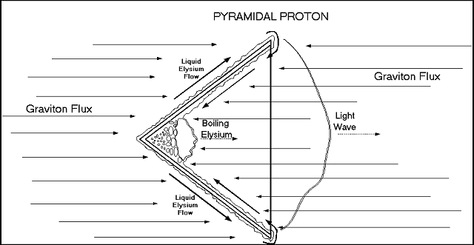
Conventional atomic physics identifies the electron as being a repulsive barrier which does not allow further approach to the atom’s nucleus. It is claimed that electrons are singular particles which travel in orbits about the nucleus. It is also claimed that electrons can emit photons – supposedly singular particles also. In this new speculation, the “electron” is actually the continuous vaporizing of liquid elysium in the proton “well”. And the shape of the proton and the continuous impact of gravitons causes a continuous supply of liquid Elysium entering the proton “well”. The vapor goes out as waves, which account for the phenomena of photons. Recall that previous section in this paper explained that photons are not particles but momentum waves in the light carrying medium – the Elysium.
The presence of this single proton – with its shape – interacts directly with elysons and indirectly with gravitons. This is thus an atom of hydrogen. The repulsive electron is the vaporizing Elysium.
In the three mediums described, the third medium being scattered protons, there is only one kind of particle needed to make up each medium. No additional particles are needed. This is a classic example of Occam’s Razor. All of the particles in all three mediums act in a passive manner; they do not attempt to do anything. They do not need to have a consciousness, a mind. They are not alive. All interaction between particles occurs by collision. There is no “secret” pure energy. Any apparent pure energy can be found to be simply particles which have mass and velocity. All transfers or transformations of energy and force simply arise from collisions of these various particles with one another.
Given the asymmetric geometry of the proton, one can derive from simple analysis the following facts:
- Any collision between a graviton and a proton on its outer surface will impart momentum from the graviton to the proton. This would presumably give a push and therefore a velocity to the proton. But, any such path of a graviton, including a change in its direction because of collision, can be negated by a graviton following this exact path in the opposite direction. Therefore, the net effect of push on the proton is zero.
- Any collision between a graviton and a proton on its inner surface will impart momentum from the graviton to the proton. This momentum transfer will cause the proton to have a velocity in the direction of its conical tip. Another graviton, following the exact same path – but in the reverse direction – does not cancel out the momentum transfer of the first graviton. Instead, it adds the same amount of momentum transfer and increase in velocity to the proton as did the first graviton. The net result is that the proton travels in the direction of its tip (of the cone). Refer to the figure below:
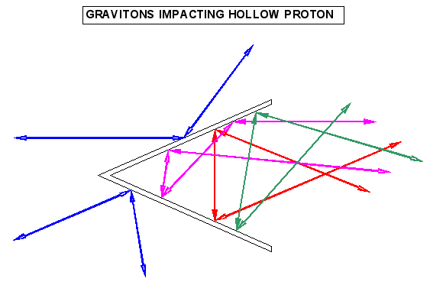
- The condensing and vaporization of elysons on the proton will also add to the forward velocity. However, much more importantly, the outside tip of the proton will not have an outward, expanding, repulsive force. It will interact with another proton only through hard contact. The base of the hollow cone proton will have a constant, outward, expanding, repulsive force of vaporizing elysons. Any other proton, which is approaching the first proton on its hollow side, would be pushed away by the vaporizing elysons. The net result is that an approach of two protons, cone tip to cone tip, is favored.
- The movement of elysons on the proton surface is always downhill, until they are vaporized. This progression is not reversible. This gives the first, fundamental explanation of why time moves “forward” and not in reverse. Classical thermodynamics claims that interactions at the atomic level are completely reversible but this is not correct.
Let’s see if there is an experiment, which backs up the speculation of an asymmetrically shaped proton:
A magnet is encapsulated within a vacuum chamber. The magnet is shaped such that the two poles point to one another, but there is a significant gap between them. At the left side of the vacuum chamber, a stream of atomic hydrogen is shot through a pin hole. As the hydrogen approaches and enters the gap between the two poles of the magnet, the gas stream splits into two equal streams. One stream goes to the North Pole and the other to the South Pole. This behavior is an actual experimental result. Refer to the figure below:
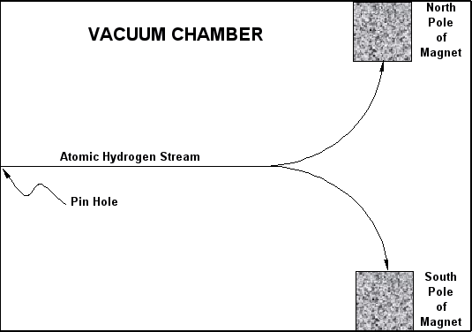
It is proposed that magnetism is simply the random gravitational flux being refocused into a bidirectional stream by the atomic geometry of the magnet. It is noteworthy that the force of magnetism is constant and never ending. It does not require any apparent energy input and it does not give off heat. It has been found to be “instantaneous” just like gravity. Let’s see what would happen to a hollow cone proton entering the magnetic “field”. The figure below shows a proton, still in a random gravitational flux, approaching the magnetic field.
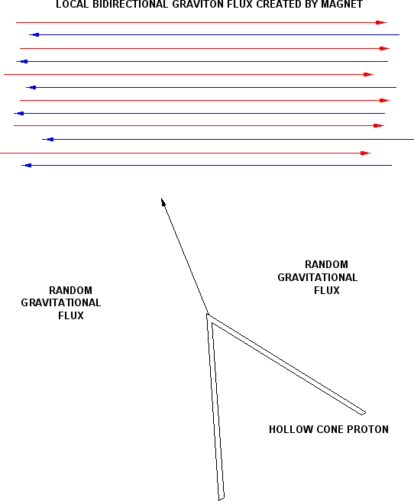
Having entered the magnetic field:
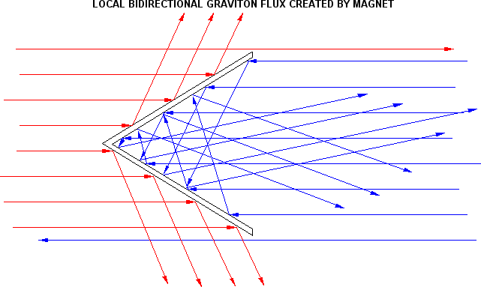
The slightest orientation of the proton tip to either magnetic pole will push the proton to that pole. As can be seen above, the gravitons impacting the outer surface will lose some momentum but continue to the right. Gravitons impacting the inner surface will have their direction basically reversed, thus granting more momentum to the proton. Since the orientation of atomic hydrogen protons is entirely random in the oncoming stream of hydrogen, sheer randomness will split the entire atomic hydrogen stream into two equal streams, each one heading to a magnetic pole. Please note that no attractive force is involved. It is all push. The protons would remain on the surface of the magnetic pole because their outer points have less of a graviton push against them than the push of the gravitons entering the inner side of the hollow proton.

HYDROGEN
The simplest molecule is the hydrogen molecule. When two hydrogen atoms come near one another – tip to tip – they shield each other from the graviton “wind” just like the Earth and the Moon shield one another. This causes a relative lack of gravitons moving along the common center line between the two atoms. They are naturally “attracted” to one another and finally line up tip to tip. Refer to the figure below:
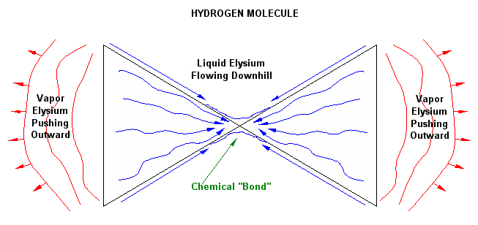
The geometry of the two atoms, touching one another, determines the local gravitational “wind”. In this situation, downhill on the outside of the hollow cone protons is now reversed and liquid Elysium flows from the base to the tip. Elysons, which have piled up against the proton and liquefied, flow towards the union of the two proton tips. This liquid forms a “glue” or chemical “bond” between the two atoms. The vaporizing elysons, coming out of the inside of the two hollow proton cones, keep pushing the two tips together. The liquid Elysium population at the chemical bond position is a dynamic population. Elysons in liquid phase are constantly flowing down the outer surface to the chemical bond position and liquid elysons are constantly evaporating at the chemical bond position. This bond, being liquid, is obviously pliable. The two hydrogen atoms can stretch, rotate and bend at this liquid point.
All chemical bonds have this character, with variations depending on the geometry of various nuclei. If two atoms have multiple chemical bonds between them, that will restrict the orientation and movement of the two atoms. For instance, that would certainly be the case for the two nitrogen atoms, which have triple bonds in the N₂ molecule. One could anticipate that, from a geometric viewpoint, the breakage of the N₂ molecule would require more disruptive energy than for the H₂ molecule.
Collision between two H₂ molecules could easily break the bonds apart and result in hydrogen atoms. Collision between two N₂ molecules would have to occur at a very high temperature (velocity) in order for N₂ triple bonds to be broken, resulting in atomic nitrogen.

DEUTERIUM
We now come to nuclear fusion. Conventional nuclear physics claims that fusion can only occur at incredibly high temperatures (millions of degrees), i.e. extremely high velocities for the nuclei. It also claims that when the nuclei fuse, there is a vast release of energy. Neither claim stands up to common sense. Various teams at universities or other government institutions have spent countless billions of dollars over the past sixty years, to create nuclear fusion reactors. They have all been spectacular failures. Fusion has not occurred and there has been no net release of energy.
The University of Wisconsin nuclear team presents a perfect example. They predicted, according to mainstream theory, that the ideal reactants for the greatest fusion release of energy would be Helium-3 nuclei. They achieved their goal of millions of degrees temperature, confinement of the Helium-3 nuclei by powerful magnets and enough time duration to get results from the countless millions of collisions. The results were no release of energy and an outward flux of 140 million protons per second. Since Helium-3 nuclei are made of three protons – not neutrons, what they achieved was fission. The colliding nuclei broke apart into singular protons.
They ignored the actual results – as did the rest of the mainstream nuclear scientists – and proclaimed that we must make a gigantic effort to go to the Moon and “mine” all of its Helium-3 for use in nuclear fusion reactors here on Earth. When one obeys dogma and stays faithful to mainstream science, there is no limit on human insanity.
Observations of newly forming stars show them surrounded by a large belt of black, opaque nebulae. Apparently, nuclear fusion can occur at “cold” temperatures!
Let’s examine the figure below:
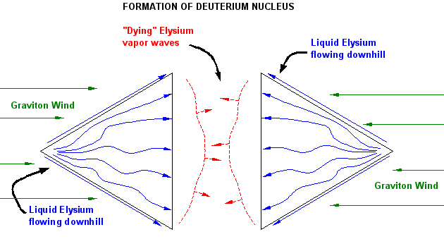
If overall gravitational pressure has compressed the molecular hydrogen nebula enough, the molecules will break apart to atomic hydrogen – due to collisions between the molecules. On rare, random occasions, when two hydrogen protons approach one another – base to base – they will once again shield one another from the gravitational “wind”. In this case, the liquid Elysium flows downhill from the cone tip to the base on each proton. Because the hollow, inner portions of the proton cones are being shielded from the graviton flux, the repulsive outflow of vaporizing Elysium will die down. But the liquid Elysium will still flow into the inside of the hollow cones. When the two cones mate – base to base – there will be a fair amount of liquid Elysium trapped inside the two cones. The graviton flux will then hold the two cones together.
Something else gets trapped inside the two cones when they mate. One or more gravitons. Even though the velocity of the graviton is about 20 billion times the speed of light, one or more of them will be trapped. If one argues that they are fast enough to escape, then they are equally fast enough to get in. The graviton is not alive and it does not have any motivation. Its behavior is absolutely passive.
Let’s suppose that the joining of two proton hollow cones captures one graviton for every one thousand elysons. Let’s even have the elysons be at room temperature, 70ºF. A plausible ratio would be for an elyson to have one millionth the mass of the proton, and a graviton have one millionth the mass of an elyson. Within the cavity, the trapped gravitons will collide with all the elysons until they all have a common temperature, i.e. a common speed. The fundamental principle here is conservation of momentum:
Mass of graviton * velocity of graviton + 1,000 * mass of elyson * velocity of elysons = a constant value.
The initial velocity of the one graviton is 20 billion times the speed of light. The initial velocity of the 1,000 elysons is “zero”. Carrying out the mathematics, the final, equilibrium velocity of each elyson is 5,996,000,000 meters per second. Or 3,726,000 miles per second. We can use the kinetic theory of gases to determine the temperature of these 1,000 elysons:
(velocity)^2 meters² / second² = 3 * R * T / M
Where:
R = gas constant = 8.314 kg * meter² / second² /mole / ºK
T = absolute temperature in degrees Kelvin
M = mass of a graviton in kilograms / mole
Carrying out the computation, we get a temperature of 14.5 million ºK. This temperature is right in the middle of observed temperature range of an atomic bomb detonation being from one million ºK to one hundred million ºK. So, the “incredible, mysterious” nuclear energy inside the nucleus is not incredible or mysterious at all. It comes from gravitons and elysons being trapped within the cavity formed by two protons joining together, base to base.
Because this deuterium molecule has no repulsive “electron” force, it is possible to form polydeuterium under pressure.

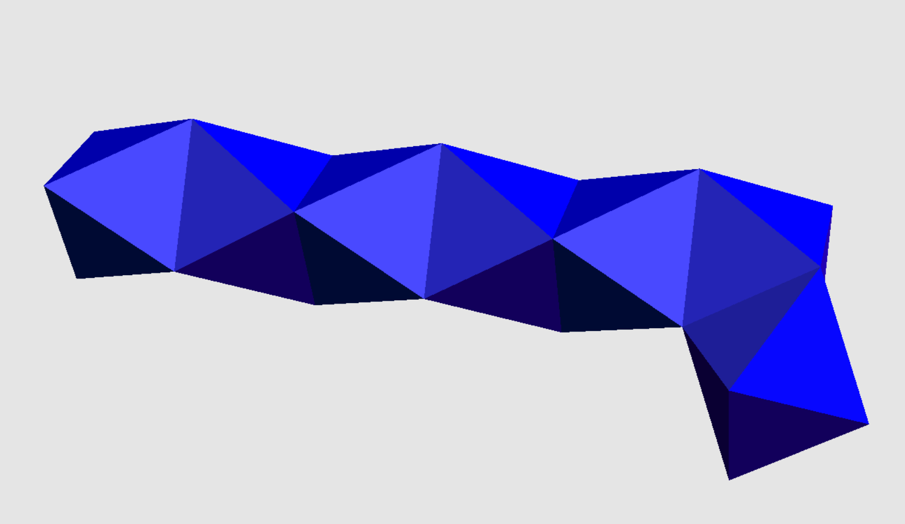

The deuterium atoms come together because they are pushed together by the gravitational flux. There is no attractive force; they are simply in each other’s way. The deuterium atoms would have a very thin layer of liquid Elysium on their pyramidal side surfaces, so this liquid Elysium probably acts as a “glue”. This nuclear fusion is the only nuclear fusion which happens. The theory that larger nuclei such as iron are formed through incredibly high velocities at temperatures of billions of degrees Kelvin is not needed. In fact, there is no evidence of stars having such temperatures at or near their surface.
There is no apparent reason or evidence that these collisions would release immense amount of energy.

THE HYDROGEN BOMB
There is much misinformation about the hydrogen bomb. To begin with, there is no hydrogen. The theory in its simplest form is that tritium and deuterium fuse together, thus releasing tremendous energy. Extremely high temperature energy must be supplied to give tritium and deuterium high enough velocities to successfully collide, fuse into helium-4 and release one neutron. Presumably this releases immense energy out of the new nucleus. Much more energy than the energy required to give high velocities to tritium and deuterium. The initial, required energy comes from fissioning plutonium-239.
However, fusion experiments with high enough velocities, have been shown to not release more energy. The best actual result claimed is a breakeven point between energy put in and energy released.
A conceptual problem begins with assuming three factors:
- A proton has a charge
- Its charge is positive.
- Positive charges repel each other.
There is no actual evidence that any of these factors exist.
It is claimed that the repulsive Coulomb force between the protons in each nucleus must be overcome by high velocity that allows the two nuclei to come close enough for the incredibly strong, very short range nuclear force to overpower the Coulomb force – which presumably is an attractive force.
Now, as described in “THE PROTON” chapter, the Coulomb repulsive force can be recognized as the pushing force given off by the vaporization of Elysium out of the hollow inside of the pyramidal proton. But, where is the evidence for a strong, very short range nuclear force that is attractive within a nucleus? Presumably it comes from the strong nuclear energy within the nucleus. But this paper has defined nuclear energy as the energy trapped inside two, mated protons in the “DEUTERIUM” chapter. This trapped energy does not exhibit either an attractive force or a repulsive force. It is isolated from everything else by the two protons it is trapped within.
In the first hydrogen bomb test, both tritium and deuterium are identified, along with the plutonium fission trigger. It is quite interesting that the deuterium had to be a condensed liquid at a cryogenic temperature (No mention is made of the thermodynamic state of the tritium). Being in a liquid state, the deuterium was in a fixed state. That is, it was not free floating. The implication is that very high velocity neutrons and tritium nuclei would impact stationary deuterium.
Tritium is shown in the following figure. Even though all sides of the tritium nucleus are not shown, each pyramidal proton has four sides. At least this tritium agrees with the mainstream science tritium of having two neutrons and one proton. Notice, with one open pyramidal proton, the release of high temperature, highly concentrated Elysium would propel the tritium nucleus as if it were a bullet.
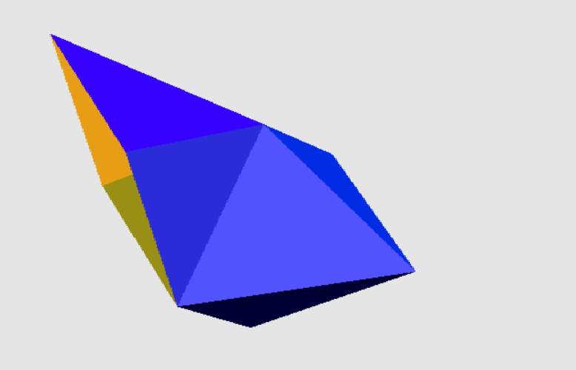
A neutron is shown in the following figure (a pyramidal four sided proton). It has been released from the plutonium fission trigger. Again, with an open pyramidal proton, the release of high temperature, highly concentrated Elysium would propel this “neutron” as if it were a bullet.

Both the tritium nuclei and neutrons would impact the stationary deuterium nuclei and split them. The result is a tremendous release of hot, expanding Elysium and two more “neutrons”. The process continues until the deuterium is exhausted. Even mainstream science states that once a neutron has lost its velocity, it is simply a proton with an “electron”. In this paper, the “electron” is simply Elysium being vaporized out of the inner portion of the hollow, pyramidal proton by the incoming graviton flux.
In the second hydrogen bomb test, lithium deuteride, a solid, was used instead of liquid, cryogenic deuterium. The theoretical design assumed that lithium-6 (plus a neutron) would be split into a helium nucleus and a tritium nucleus. The detonation released 3 times the energy calculated. On examining the lithium, it was found that over 60% of the lithium was lithium-7. It was proposed that the lithium-7, on absorbing a neutron, would fission into a helium nucleus, a lithium nucleus and a neutron. There is not any difference in the amount of tritium, so extra energy would have come from the helium nucleus. But, according to mainstream fusion theory, helium is dead ash. There is no energy to be extracted from it.
The above experimental results bring into doubt that any fusion occurred and that any energy was released by nuclear fusion. More likely, the process was entirely fission. I am proposing that the only source of energy release is by fission.

THE SOLAR SYSTEM
The conventional theory of solar system formation states that a nebula of mostly hydrogen and dust was caused to collapse inward due to one supernova or perhaps two supernovae or possibly three supernovae. The dust is never identified in terms of composition. Reference is made to heavier atomic elements having been created by supernovae because “anything can happen in a supernova”. No mention is made of Elysium being present within the nebula.
Since the Universe has always existed, the presence of heavier elements in the nebula does not need nearby supernovae to account for their existence. Nor does the “dust”. It is then stated that as the nebula slowly collapses it begins to have an increasing spin rate due to the conservation of angular momentum.
Correct.
However, it is then claimed that the dust particles begin to collide and accrete into larger bodies, eventually becoming asteroids. Then asteroids collide and combine to form planets. There are many problems wrong with this theory:
- Why would dust particles accrete? They would collide at high velocities relative to their minute gravitational “attraction” and probably fly apart. Assuming they are of natural matter, it is unlikely that they would be attractive to one another.
- The composition of the dust particles would be random, so there is no reason why an asteroid would show distinct mineral layers – but they do.
- Asteroids are hard and dense; they are not “dust bags”.
- The asteroid belt is a direct contradiction that asteroids would come together to form a planet.
- Minerals identified on the asteroid Eros have melting (and therefore freezing) temperatures of 1,200 degrees F to 1,800 degrees F. How is this temperature range achieved by colliding dust particles? Eros had to undergo a melt stage in order for the molecules of these minerals to bond with one another.
Below are photographs of Eros:
Putting aside asteroid theory, the photographs give the appearance of a rounded, melted body. In addition, the craters are “soft”, as if the impacts happened when the asteroid was in a melted state. This is in sharp contrast to craters on the Moon.
Heinrich Olbers, one of the first discoverers of asteroids, proposed that the asteroid belt was the remains of an exploded planet. Although there is no known cause for a planetary explosion, such an event can account for the “melted” asteroids of the asteroid belt. Their total mass is quite small, so most of the “exploded” planet would have left the solar system. Such an explosion would provide the heat needed for “melted” asteroids. Radiation from the Sun would not provide the thermal energy for “melted” asteroids at the distance of the asteroid belt.

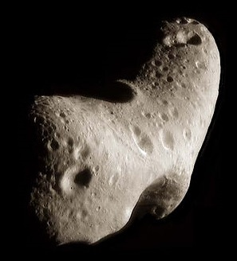

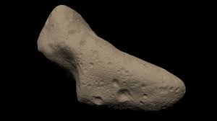
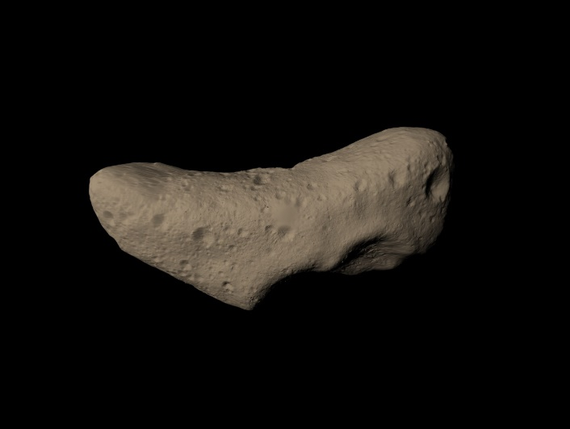

Mainstream theory points out that the temperature of the nebula is far below that required for hydrogen to fuse into helium. So, the hydrogen nuclear fusion cannot contribute to the formation of asteroids, whatever their size. Planets have fixed orbits. How is this achieved by the accretion of dust particles?
The standard theory of solar system creation completely ignores the presence of a light carrying medium, Elysium, because the mainstream theory assumes there is no light carrying medium. This issue was discussed in the chapter “LIGHT”.
Let’s begin with a new start to solar system creation. We need only protons and the elysons of the light carrying medium in the vast nebula. Obviously, the gravitational flux will cause the initial nebula to contract. As the concentration of protons and elysons increases, some of the protons will mate together as described in the chapter “DEUTERIUM”. Remember that the surfaces of the deuterium nuclei would have thin layer of liquid Elysium even though the surrounding Elysium is still a vapor. This liquid would act as a sticky substance when deuterium nuclei meet face to face.
Such polydeuterium structures would grow randomly and come together, pushed by the graviton flux. This growing structure would be extremely dense. It will continue to grow because the concentrated Elysium will protect it from high speed collisions by alpha particles, neutrons, etc. Because of its growing mass, its inertial mass would keep it in a progressively fixed orbit around the center of the nebula. That is, with high nuclear density, the gravitational flux may not penetrate to the center of the polydeuterium mass. In that case the total mass will be greater than the gravitationally effected mass. Since the gravitational force is finite, the mass may be highly resistant to having its orbit changed. However, the remaining, scattered elysons and protons would collapse inward under the force of gravity. In time, the polydeuterium structure, which could be of planetary size, will be left alone in its orbit.
As the protons and light carrying medium contract inward, the process of forming deuterium and then polydeuterium would begin again. Another planetary polydeuterium structure would form and remain in its orbit. This process would repeat until the concentration of elysons is so high that it begins to condense on its own. This is the beginning of a star. At this point, a significant fraction of the star is liquid Elysium.

THE SUN
Our Sun formed like other stars. It is said to be 73% hydrogen, 25% helium and 2% of other relative light elements. Because of the temperature of the Sun’s surface and inward, it is claimed that it is entirely gaseous – right to the center of the Sun. This would certainly be true for hydrogen and helium, because the temperature is far above the critical temperature of each element. The critical temperature is where the physical difference between vapor and liquid ceases to exist. However, mainstream science does not recognize the existence of a light carrying medium – the Elysium. The Sun is actually a liquid with a significant content of protons and liquid elysons. There are a number of observational datum, which strongly indicate that this is the case. The following observations were reported by Pierre-Marie Robitaille, Ph.D. The Ohio State University, Columbus, Ohio:
- If the Sun were a vapor, there could not be a continuous thermal spectrum. The vapors of hydrogen, helium, and so on radiated only specific bands of color. A liquid phase Sun can and does give off a continuous spectrum of color.
- The Sun exhibits light darkening as one views from the center of Sun to the edge. This is not possible with a gas phase but is normal for a liquid phase.
- If the Sun were gaseous, then the Sun would collapse inward under the pressure of gravity. A vapor pressure offsetting the push of gravity would absolutely require a liquid rigid surface and relative incompressibility is the characteristic of a liquid phase.
- The specific density of the Sun is too high for it to be a vapor phase. But a liquid phase can easily account for the average density of 1.4 grams per cubic centimeter.
- The Sun exhibits properties of seismology. That is, pressure waves. However, the gaseous model of the Sun sets the density of the photosphere at 10^{^(-7)} grams per cubic centimeter. This is an extreme vacuum and such a vacuum cannot exhibit seismic waves. A liquid phase Sun can easily show seismic waves.
- With a solar flare, the Sun shows the propagation of waves much like a pebble thrown into water. This is impossible for a vapor phase, but obviously a property of a liquid phase.
- The Sun is not a perfect sphere but is oblate. This is possible only if the solar density is relatively constant. It is not possible for a vapor phase but is obviously consistent with a liquid phase.
- Superheated liquid easily explains solar flares since they represent the boiling action of a liquid. A gaseous phase cannot explain solar flares.
- The Sun shows pronounced flows at the surface mostly in a horizontal direction whereas the corona shows flows in the vertical direction. This is equivalent to Earth’s ocean and the atmosphere. This is not possible for a vapor phase Sun.
- The Swedish Solar Telescope has taken images of the Sun’s surface at high resolution in 3D. It shows valleys, canyons and walls.
The above observations indicate that the Sun is primarily condensed Elysium which is boiling. There is undoubtedly nuclear fusion and nuclear fission occurring. Based on previous chapters, nuclear fusion encapsulates energy and nuclear fission releases encapsulated energy. This brings into serious doubt that the Sun maintains its thermal radiation due to either nuclear fusion or nuclear fission. A far more simpler and long term constant explanation is that the gravitational flux impacts the liquid Elysium and causes it to remain very hot and boil.
There would be a constant exchange between vapor Elysium being driven into the Sun by the gravitational flux and being condensed, while other liquid Elysium is being boiled and vaporized by the constant, incoming gravitational flux. The Sun shows highly irregular surface activity which would be consistent with condensation and vaporization occurring at different locations.
Sunspots are actually black. Photographs of the Sun show, objectively, that sunspots give off no light and thus are black. In the previous chapter “DEUTERIUM”, it was demonstrated that deuterium has no open, hollow proton pyramids which cause trapped, liquid Elysium to be vaporized by the graviton flux, which we see as the emission of light. So a sunspot is very likely a huge, random structure of polydeuterium. Sunspots occur near the polar region on the Sun. They grow and simultaneously move toward the equator of the Sun. Then they “disappear”. A plausible possibility is that they collide with one another. This collision of incredibly huge masses could result in their undergoing a rapid nuclear fission. This could release enough energy to cause flares which erupt out of the Sun.
The following figures show sunspots and the Earth. It can be seen that sunspots easily exceed the size of the Earth. The third picture shows the “iris” around the black sunspot. This iris would represent newly formed polydeuterium flowing inward to attach to the sunspot. This is not attraction but the pushing of “piecemeal” polydeuterium until it collides with the surface of the sunspot.



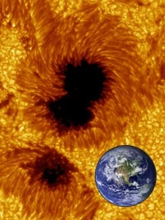


A collision of huge sunspots would result in fragmentation of the polydeuterium structures into a vast array of atomic elements. More to the point, there are about 3,340 isotopes for the elements in the periodic table. Most are radioactive and breakdown. The indication is that their creation is entirely random. The human organization of them into the periodic table and to assigning various isotopes to particular elements is useful to us but it has no meaning or relevance to Reality. There is no organized, intentional creation to them. It is entirely by chance.

SUPERNOVA
The mainstream science of a supernova, in simplest terms, is that the star runs out of reactants that can undergo nuclear fusion and release energy. This presumed release of energy by nuclear fusion is supposed to keep the star from experiencing gravitational collapse. Once the inner core has become primarily iron, there is no longer a release of energy by nuclear fusion because any element heavier than iron, that is created by nuclear fusion, consumes energy rather than releases energy. The vapor phase star collapses inward, forming a “neutron” like core, and then “bounces outward” blowing most of the star away with an incredible release of energy. This sudden source of energy is not made clear. With the expanding supernova, all elements heavier than iron are created because “anything can happen in a supernova”.
There are problems with this theory:
- There is no hard evidence that nuclear fusion releases energy – simply a theory.
- In the previous chapter “THE SUN” there was considerable evidence given that the Sun is a liquid and liquids do not collapse inward – contrary to the gaseous star defined by mainstream science.
- Observed supernovae exhibit high brightness for days or even weeks. Not exactly the characteristic of an explosion that is said to occur in seconds.
- Since the presumed release of energy in the star only comes from nuclear fusion, and then when further nuclear fusion will not release energy, where does this incredible amount of new energy come from?
An alternative explanation for a supernova will be described. Sunspots, which are actually black, are said to represent the polymerization of deuterium in this paper. There is always an “iris” around a black hole, which indicates deuterium being pushed inward to the sun spot. Sunspots begin well above or below the Sun’s equator. They grow and slowly migrate to the equator. Then they disappear. A plausible reason for the disappearance is that they collide with one another and explode – probably leading to the massive flares that rise out of the Sun. Over a very long period of time, polydeuterium fragments may descend to the center of the Sun – if the collisions took away angular momentum from the fragments. If these fragments, which are giant nuclear spheres, come together at the Sun’s center, then they would completely reflect gravitons which arrived at their location. These gravitons would then speed outward out of the Sun. This “total” reflection of the gravitons would then further raise the temperature of the liquid Sun and literally boil off the liquid Elysium that the Sun is largely made of. This would not be an explosion but longer term boiling away of the liquid Elysium of the Sun. The brightness of the supernova would gradually decline because the boiling action would progressively boil off all the liquid Elysium until there was none left.
The polydeuterium nuclear mass at the center of the star would have the same effect on liquid Elysium as does the inner most point in a hollow, pyramidal proton. The liquid Elysium has been pushed into a “corner” and the only way out is by vaporization.

THE EARTH
The conventional theory for the creation of the Earth is common for all terrestrial planets. In the beginning some pushing force initiated the gravitational collapse of a huge nebula, which consisted of hydrogen and dust. No explanation is given for what the dust is or how it formed. As the nebula contracted it formed a disk of material, which is understandable because there has to be conservation of angular momentum. It is then claimed that the dust becomes white hot, apparently due to collisions. Since the outer space of the nebula would be only several degrees above absolute zero, there is no cause for dust collisions to become or remain white hot. So, there is no reason for them to stick together. But conventional theory states that dust collisions give pebbles, which in turn become boulders, which in turn become asteroids, which finally become the Earth through many, accreting collisions. The Sun is slowly forming so there is no apparent external, nuclear heat source.
At this point the Earth is fiery hot with volcanoes and much lava. Somehow, some water appears, which tends to cool down the surface of the Earth. Really?
Then a multitude of ice comets impact the Earth, supplying most of the water we have today. How did icy comets form if dust collisions result in white hot matter? Since the comet velocities could range from 20 miles per second to 50 miles per second, how does this high velocity impact result in water?
The following diagram shows the various layers within the Earth:
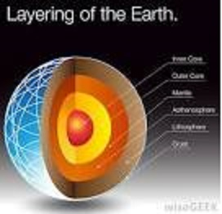

Let’s take a rational look at planet formation. In the chapter “DEUTERIUM”, it was explained how hydrogen atoms could convert to deuterium. Then deuterium nuclei can stick together and become polydeuterium. High velocity and temperature not needed. Eventually the polydeuterium ball would reach the mass of a planet. As explained in the chapter “THE SOLAR SYSTEM” the newborn planet would retain its orbit while the rest of the hydrogen and elysons would collapse inward. Once the planet is exposed to an Elysium free outer space, any incoming nuclear particle would impact the polydeuterium ball and initiate radioactive breakdown on the surface of the ball. Such radioactive breakdown would continuously supply an immense number of nuclear particles, which would again initiate further radioactive breakdown on the polydeuterium ball surface. This would continue endlessly.
Such a radioactive breakdown on the polydeuterium surface would produce, in a random manner, all the elements of the periodic table and all known 3,340 isotopes. With the high temperature at this surface, there would be the eventual creation of all the compounds we commonly observe: hydrogen gas, nitrogen gas, carbon dioxide, water, hydrocarbons and so on. Because of the Earth’s gravity and orbital position relative to the Sun, a few molecules such as hydrogen will not be retained by the Earth. The so called fossil fuels: coal, oil, natural gas would come into being as elements combined together into molecules.
Eventually the created, normal molecules and crystals would begin to settle with heavier material at the bottom and lighter material rising to the top of the mantle. There would be, gradually the formation of the Earth’s crust and mantle. Continuously, over many millions of years, there would be the formation of volcanoes and continents. The mantle is said to be composed of silica and various metal. Probably true. The inner core has been determined to be a rigid solid, based upon the reflection of seismic waves. The conventional explanation is that it is a mixture of iron and nickel. However, at a temperature of 5,400 degrees F, these elements would be a fluid. The selection of iron / nickel is based on the Earth’s weak magnetic field. However, based upon this paper’s theory of polydeuterium, that is the substance that would the solid, rigid core. This would be polydeuterium which has not yet disintegrated by radioactive decay, with that decay occurring only on the surface of the polydeuterium ball.
In a later chapter we will identify what magnetism is and why a polydeuterium ball may cause a weak magnetic field.

PLANETARY RINGS AND MOONS
If a planet is born as a polydeuterium ball, then the speed of rotation is very high. As the surface of the ball undergoes radioactive breakdown to create normal molecules and crystals, the rotation rate remains high because almost all of the mass is still in the polydeuterium ball. Since the normal matter occupies much more volume, its rotational velocity is very high and normal matter begins to break away from the polydeuterium ball. This velocity is highest at the equator so the planet forms rings much like Saturn.
For terrestrial planets, the ambient temperature from the Sun will evaporate this material, which most likely is composed of gases and water. Thus, after a long period of time, these terrestrial planets will not exhibit any rings. For the gas giants Jupiter, Saturn, Uranus and Neptune, the ambient temperature is cold enough that water will freeze rather than evaporate. So, we observe rings around these gas giants. The rings are probably composed of almost entirely of water. With the gas giants, their high gravity plus very cold temperature leaves most of the gases within these planets – even hydrogen.
In December, 2012, astronomers confirmed that there are rogue or orphan planets. That is, planets that are not within a solar system but are wandering freely. Apparently, such planets are very common. If a true planet has a polydeuterium core, then its gravitational field is largely set by the amount of normal material surrounding the nuclear ball. Therefore, the total inertial mass of the planet may significantly exceed the calculated gravitational mass based upon the strength of its gravity. This means that the planet’s orbit or trajectory may be substantially more stable than we would predict.
Moons may come into being because of a close approach between planets. This could be caused by an orphan planet entering our solar system and then leaving. If planets are close then they mutually block the gravitational flux between them. Given that both planets have rotation, a large amount of surface material may escape from each planet. With the presence of both planets having gravitational influence on this material, it would tend to form a cluster. Under the general influence of all the gravitational flux, the cluster would compact to a sphere, which is the most stable geometry. There would then be a small “planet”.
The close passage of two planets near one another might take about two months, given the typical velocity of the planets we know. This kind of close encounter is the most likely cause of the creation of our Moon. It is apparently mostly crustal material ripped off where the Pacific Ocean lies.
It should be noted that these moons would not have a solid nuclear core. Therefore, the orbit of such a moon could be easily changed in comparison to a planet.
A couple of our planets have the characteristic of moons. Mars and Venus have no core nor a magnetic field. Mars might have been a moon of the planet that now exists as the Asteroid Belt. A collision between a planet in the orbit of the Asteroid Belt and an orphan planet could result in an explosion which throws most of the material out of the Solar System. Mars, no longer having a parent planet, would begin to orbit the Sun as if it was a planet. Venus is made of material that would literally melt off Mercury, form a sphere, and slowly but definitely drift away to a larger orbit. At the orbit of mercury, the material of Venus would be liquid. As Venus drifted to a larger orbit, its material would slowly solidify.

TRITIUM
This paper agrees with mainstream science that tritium contains two neutrons and one proton. However, we define the two neutrons as two protons joined base to base so that internal energy is contained within the interior of the two protons. The figure below contains tritium at four different perspectives:


Any release of hot, enclosed Elysium from another source will flow into the open interior of the proton and drive it forward as if it were a rocket. So, with tritium at high velocity, it could split open two protons that are joined base to base, that is deuterium, thus releasing immense energy.
Tritium nuclei would always be moving. It is not a surprise that a collection of tritium nuclei would have a relatively short half-life. In agreement with mainstream science, tritium radioactively decays to helium 3.

HELIUM 3
Mainstream science claims that helium 3 has two protons and one neutron. This is incorrect. It actually has three protons, joined face to face. Four perspectives are shown below:

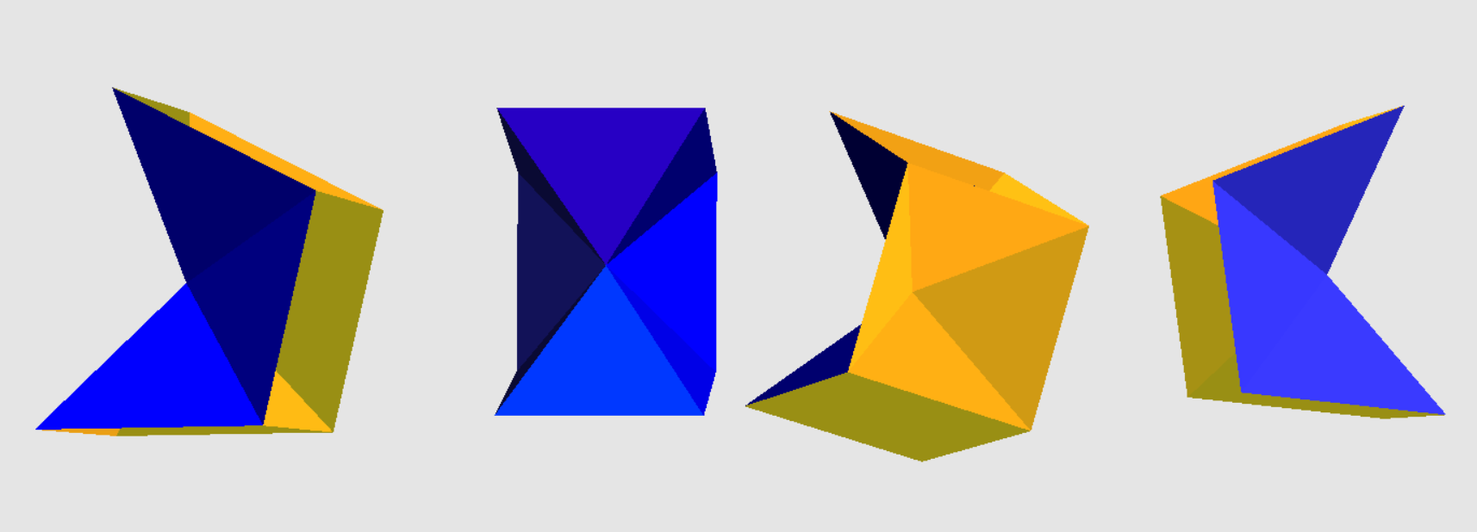

Here the three protons are attached face to face in a straight line. All blue shades represent the outside of a hollow pyramidal proton. All yellow shades represent the interior of the hollow pyramidal proton. There is, however, an alternate assembly:



Since there are no “neutrons”, there is no significant energy to be released by nuclear fission. Since it has been explained that nuclear fusion encapsulates energy, fusion will not release any energy.
One interesting experimental fact is that two helium atoms can join to form a dimer. Two versions of this are in the figure below:
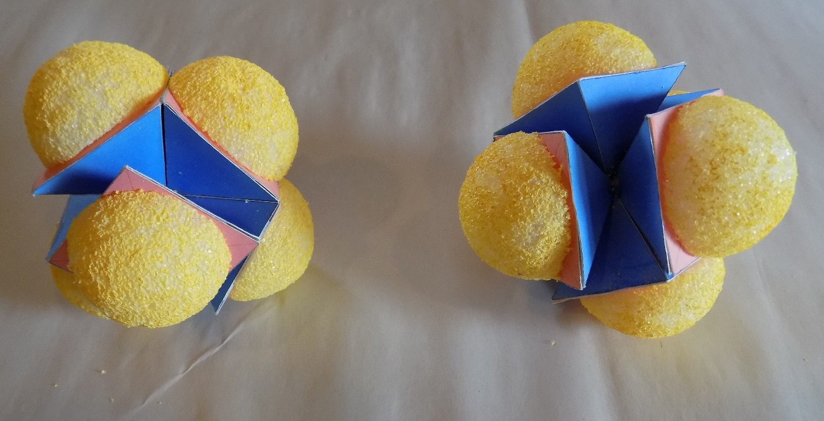

In this picture the two forms of helium 3 are combined into dimers. The yellow half balls represent the outward expansion of liquid elysons into vapor elysons as they are vaporized by the incoming gravitons (being trapped within the hollow pyramidal proton, the liquid elysons can no longer retreat away from the gravitational flux). This is equivalent to the classical Coulomb force around a nucleus or the electrons, if you prefer.
Helium 3 dimers exhibit interesting behavior. As a liquid, they can climb out of glass tube; go through extremely tiny holes; show no friction or viscosity at all; apparently float.
Because mainstream science decrees that helium 3 has two protons and one neutron, many theoretical predictions go awry. It is a Bose-Einstein liquid, but it is a Fermi liquid, but has one half spin. Some of its magnetic behavior indicates that superstrings appeared at the first instant of the big bang. All quite breathtaking.
However, this writer resides in the no spin zone:
The helium 3 nuclei form a dimer because they are literally pushed together. No attractive force is involved. Each nucleus is simply forced against the other nucleus when there is no gravitational flux between them. Once connected, they put out the classic Coulomb repulsive force in all directions. The dimers cannot come close to each other, so there is no friction. The “liquid” helium 3, at extremely low temperature, is not really a liquid since there is absolutely no bonding between the molecules.
So the “strange” behavior is directly predicted by the geometry of the helium 3 dimers.

HELIUM 4
Helium 4 is the common helium. A figure is given below with three perspectives:



As can be seen, two protons are joined base to base and two protons are attached on outer faces of the two joined protons. This leaves two protons with exposed hollow interiors, which means that liquid elysons are being evaporated out of these hollow interiors by the incoming graviton flux. There are no exposed pyramidal proton tips which can form a chemical bond with other nuclei. A chemical bond cannot form when there is geometric interference by open, hollow protons, which are emitting vaporized elysons. Refer the chapter “HYDROGEN” for the description of a chemical bond.
It is claimed that helium 4 can form a dimer and that there is “sort of, kind of” a chemical bond. But they measure the chemical bond strength as being one five thousandth the strength of a hydrogen molecular bond. This is not a chemical bond. It is interesting that there would be a poor geometric fit between two helium 4 atoms. Below are two pictures of a helium 4 dimer. It is geometrically obvious the helium 4 dimer would break apart far more easily than the helium 3 dimer. Once again, the yellow half spheres represent the outward, repulsive flow of vaporized elysons. The blue shades are the outer surfaces of hollow, pyramid shaped protons.
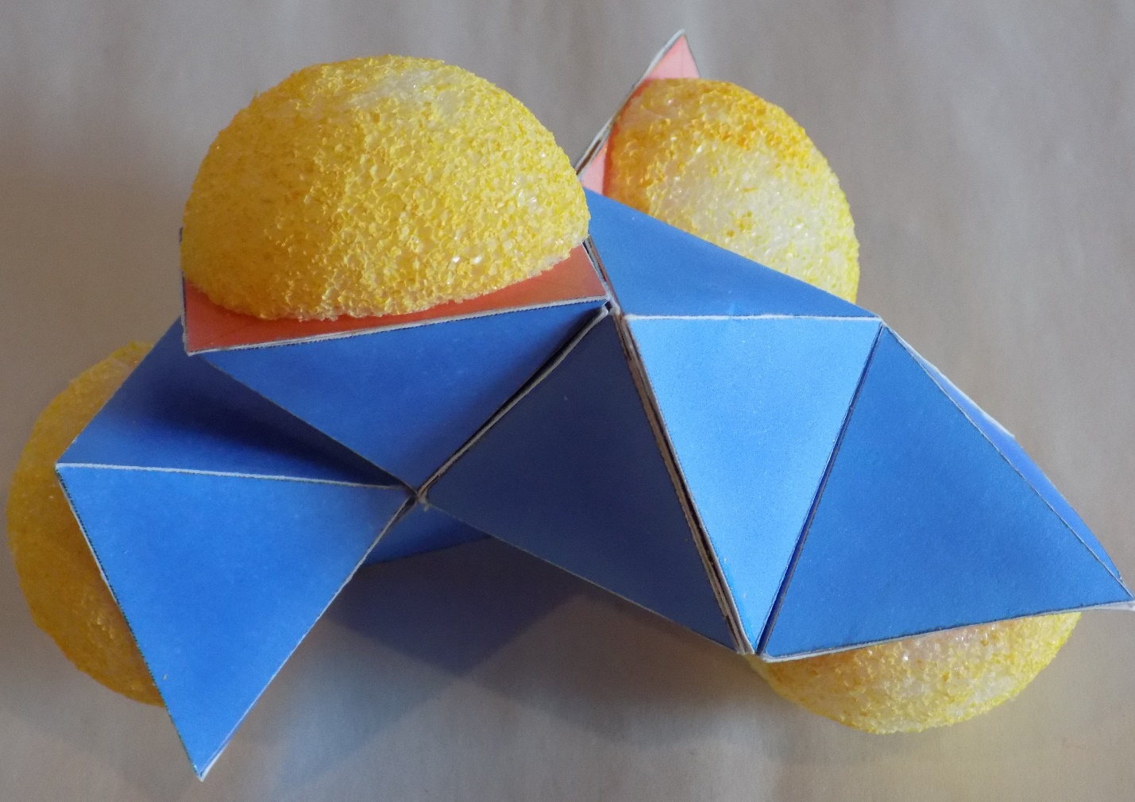

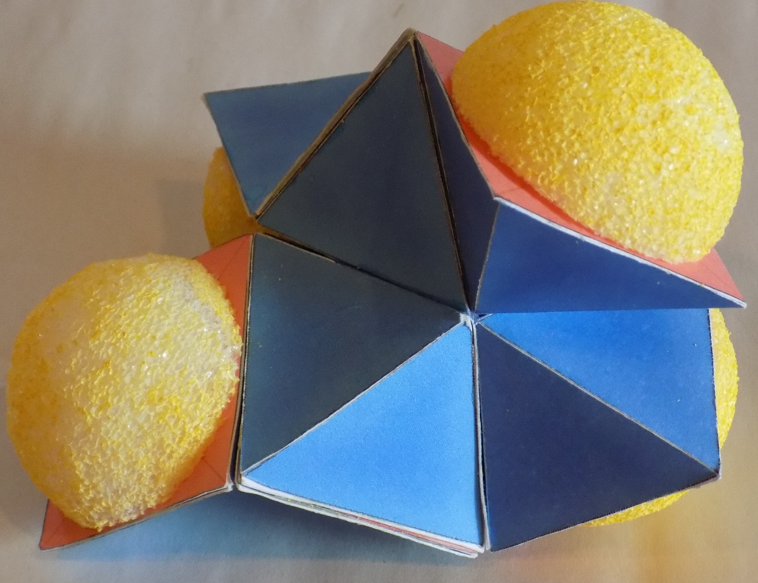

LITHIUM
Lithium exists with two stable isotopes: Lithium-6 and Lithium-7. We will examine Lithium-6 first. In both cases lithium has only one bonding point, which will be the tip of a pyramidal proton with no interference from repulsive, vaporizing elysons. Figure below shows Lithium-6 with the exposed proton tip pointed out by a red arrow:

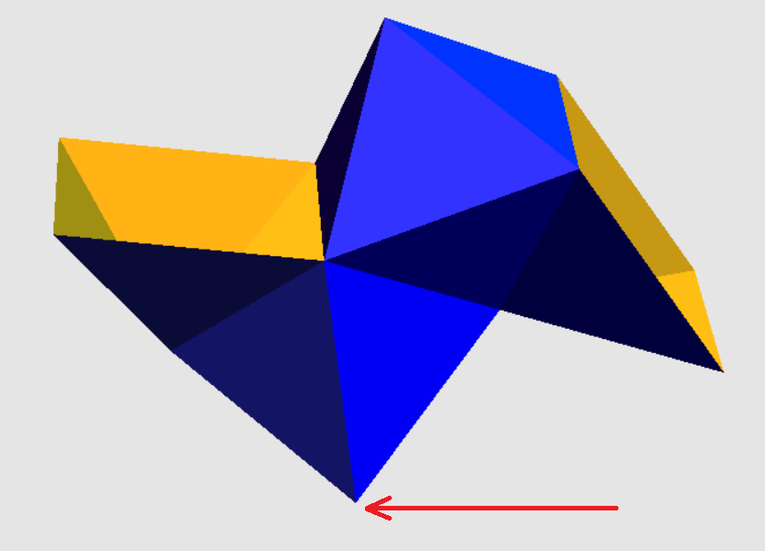

The figure below shows a Hydrogen atom chemically bonded to the exposed pyramidal proton tip on the Lithium-6 nucleus. There is now repulsion around this molecule with no exposed proton tips that are free of interference by vaporizing elysons. No further chemical bonding can take place.


There can be nuclear isomers of isotopes just like there can be isomers for molecules. And the nuclear isomers are stable. In the picture below is Lithium 7 Hydride and Lithium 6 Hydride. The only place for chemical bonding is where the tip of the Hydrogen proton can touch the only tip of Lithium 6 or Lithium 7. The yellow half sphere represent the repulsive out pouring of elysons vaporized by gravitons. One could call these repulsive half spheres “electrons”. However, they have nothing to do with chemical bonds. Where ever they are, a chemical bond cannot exist. Keep in mind, as described in the chapter “HYDROGEN”, liquid elysons are pushed by gravitons down to the chemical bond point, where they act as a kind of “glue”. The chemical bond still has the ability to bend, oscillate and rotate.
In the picture below, Lithium 7 Hydride is on the left and Lithium 6 Hydride is on the right. There is no design or plan to Lithium 6 or Lithium 7 nuclei. They are simply fragments created when the surface of the polydeuterium ball undergoes radioactive disintegration. If the fragment has a nuclear weight of six or seven, and it has one bonding point, it is Lithium.

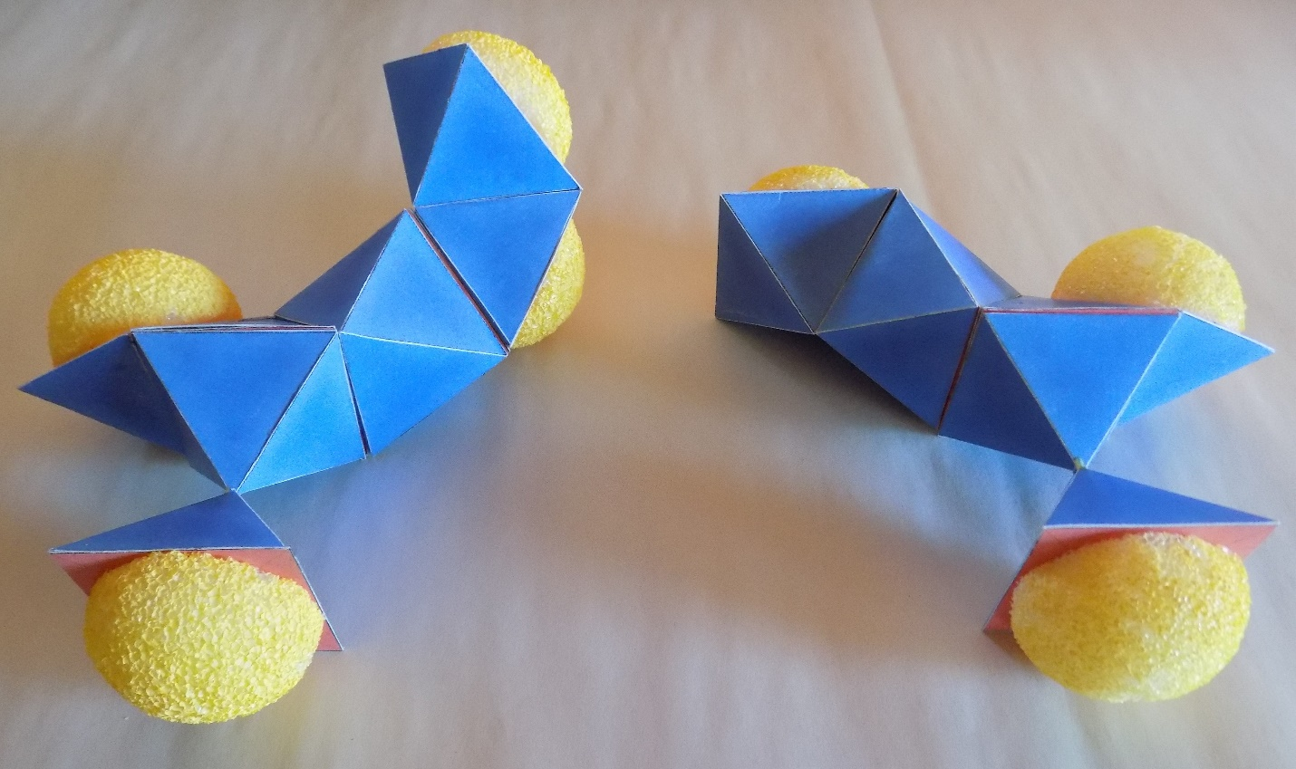

BERYLLIUM

Beryllium is the lowest mass element to have a co-valent bond, which in conventional chemistry means that two electrons are involved in the bond. However, based on this interpretation of nuclei, the Beryllium nucleus has two bonding points, which are close two one another and more or less parallel. Beryllium hydride is shown below:

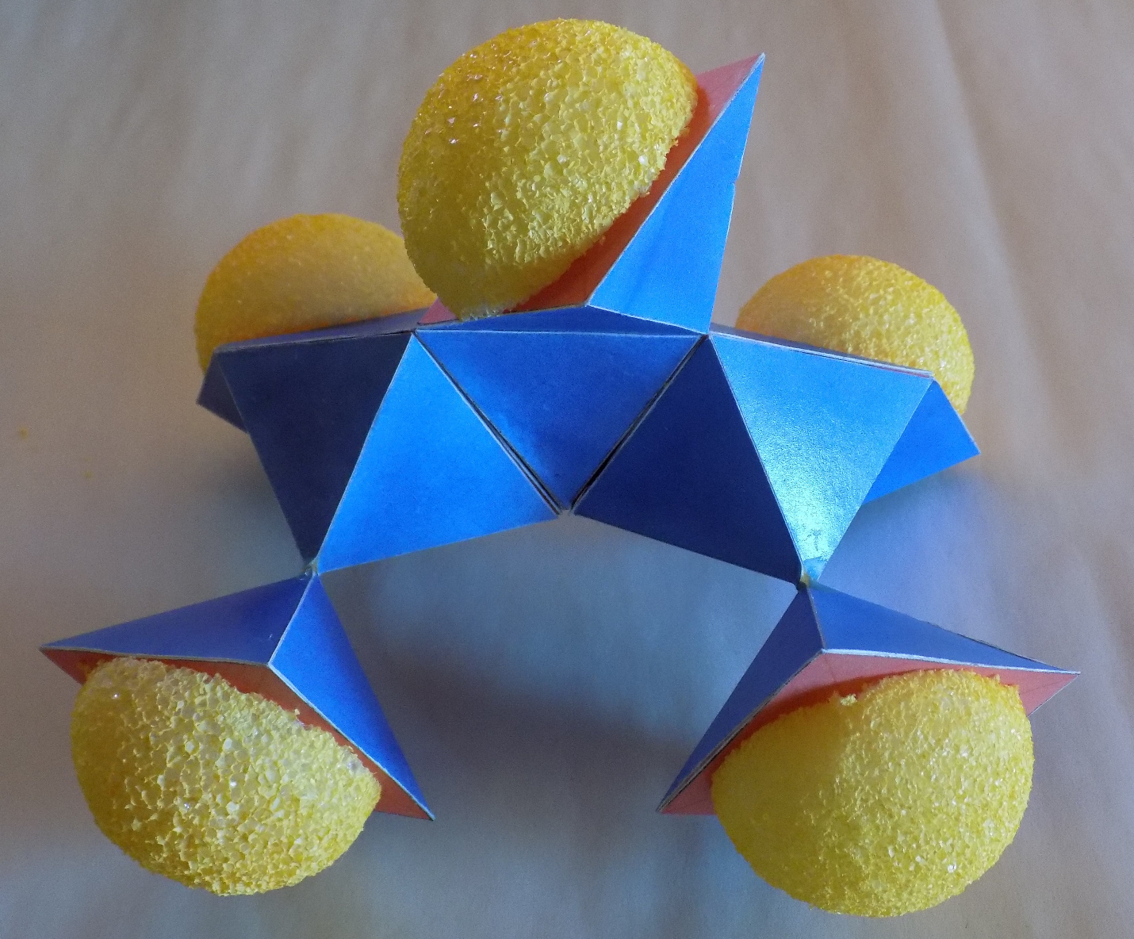

Three open, hollow, pyramidal protons are shown above. Their output of repulsive, vaporizing elysons prevents chemical bonding in that area. Two hydrogen atoms are attached to the proton tip points below. With this attachment, no further chemical bonding can occur.

BORON
Boron has only two isotopes and it has triple bonding points. In the figure below, the repulsive vaporizing elysons are shown coming out of the “top” of the boron trihydride molecule.

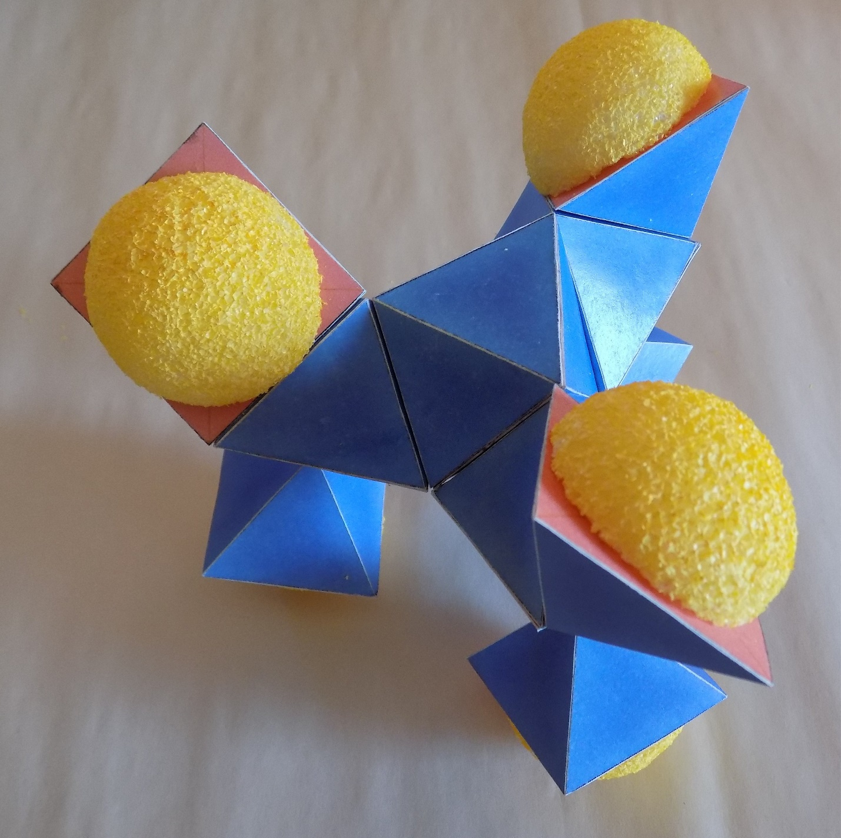

The three bonding points for hydrogen atoms are shown in the following figure. Here the boron trihydride molecule is shown lying on its “side”.
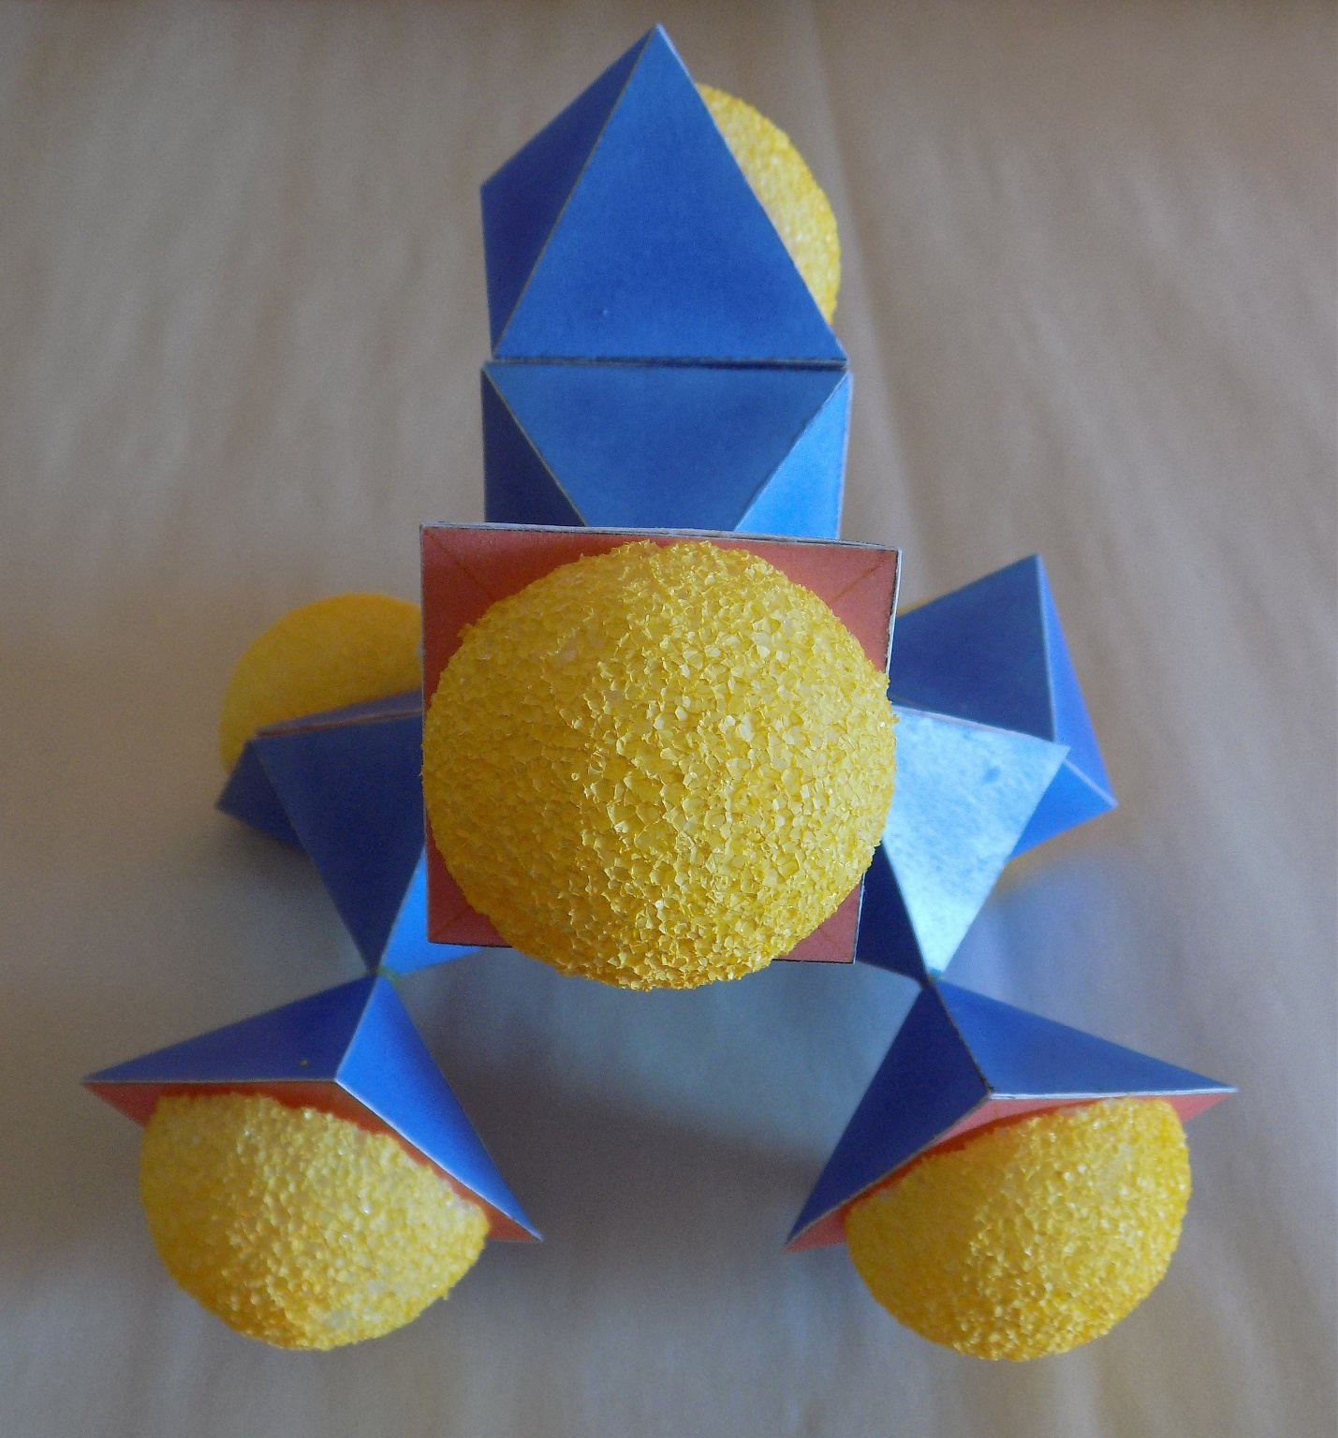

In the last picture the boron trihydride molecule is shown “upside down” with its three hydrogen atoms on top.
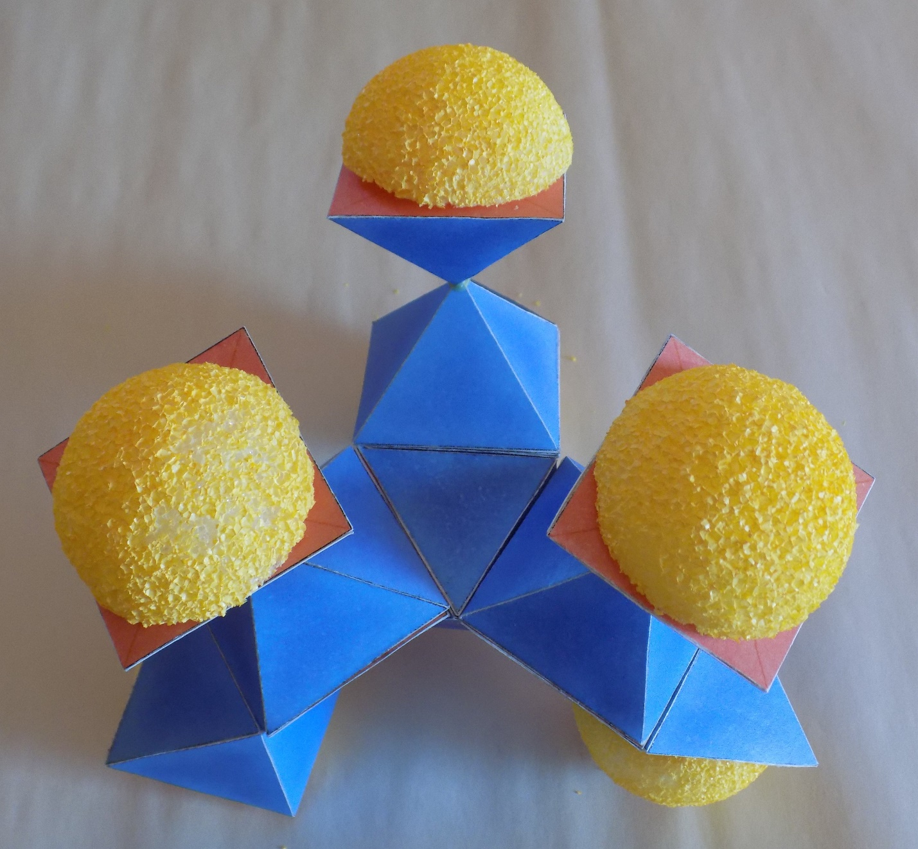

CARBON
Carbon is probably the element most studied for where its chemical bonds are located. They are each separated from one another by about 109 degrees. Given that, the nuclear structure has to be centrally located and has to have two open, hollow pyramidal protons located somewhat remote from the chemical bond locations. In the figure below, all four chemical bond positions are attached to hydrogen atoms. One repulsive position of the carbon nucleus is shown.
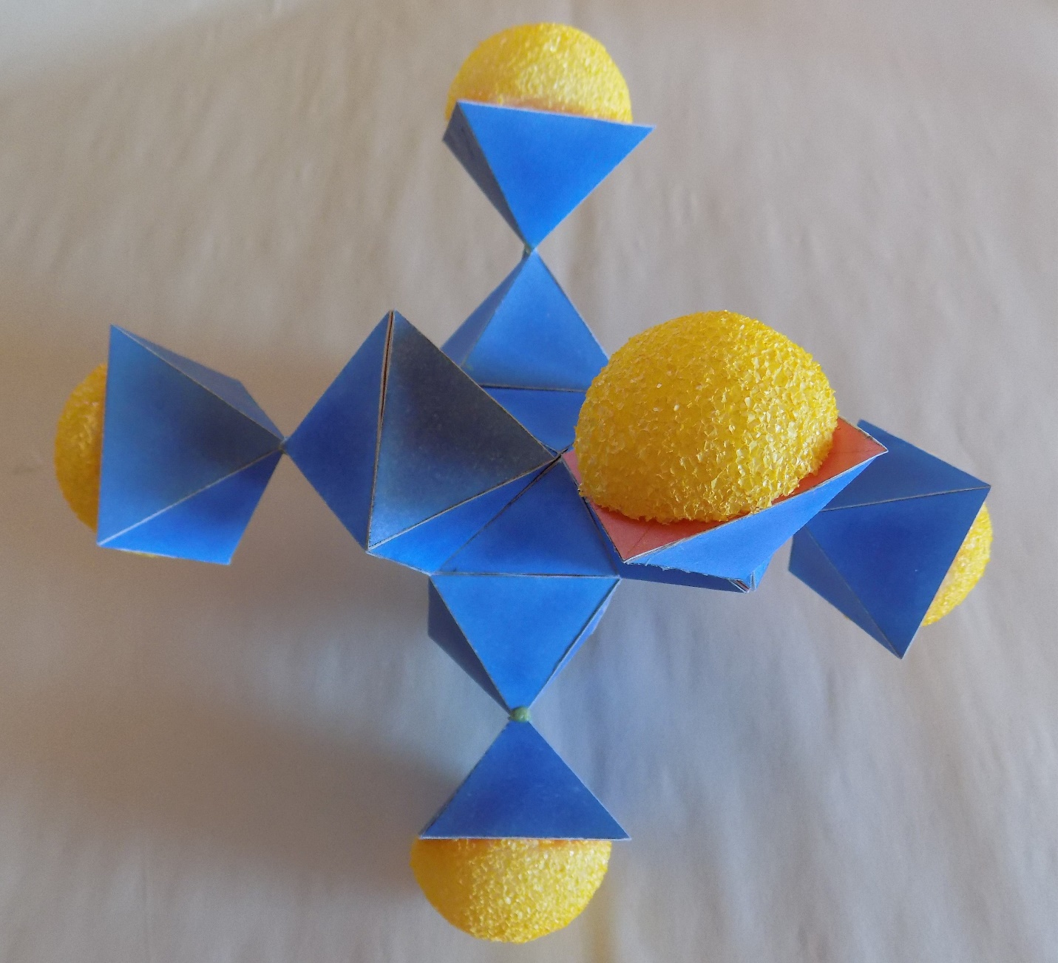

In the figure below, the two repulsive positions of the carbon nucleus are shown with three of the four hydrogen bonds positions shown.
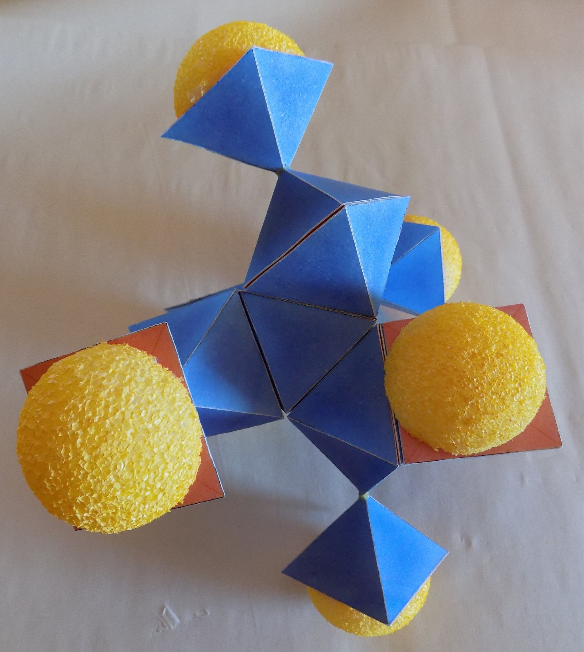

Chemists for decades have been building geometric models of molecules. Within these models the bond positions of atoms have been made clear except the atom is always represented as a sphere. The logical step forward is to stop using the Rutherford – Bohr – Pauling “solar system” sphere and begin using the nuclear structures given for the above atomic elements. These nuclear structures are certainly in line with the geometric models of molecules. This makes far more sense than attributing chemical bonds to electrons whizzing around.

NITROGEN
Nitrogen is an interesting element in that it is the first species that combines with itself as N₂ and then is highly resistance to chemical reaction. To convert it to ammonia, for instance, requires a solid catalyst. It does not react with oxygen except in the direct presence of radioactivity which breaks the N₂ triple bond. High temperature and high pressure alone will not break the triple molecular bond. The picture below shows the N₂ molecule with red arrows designating the triple bonds between the two nitrogen atoms.
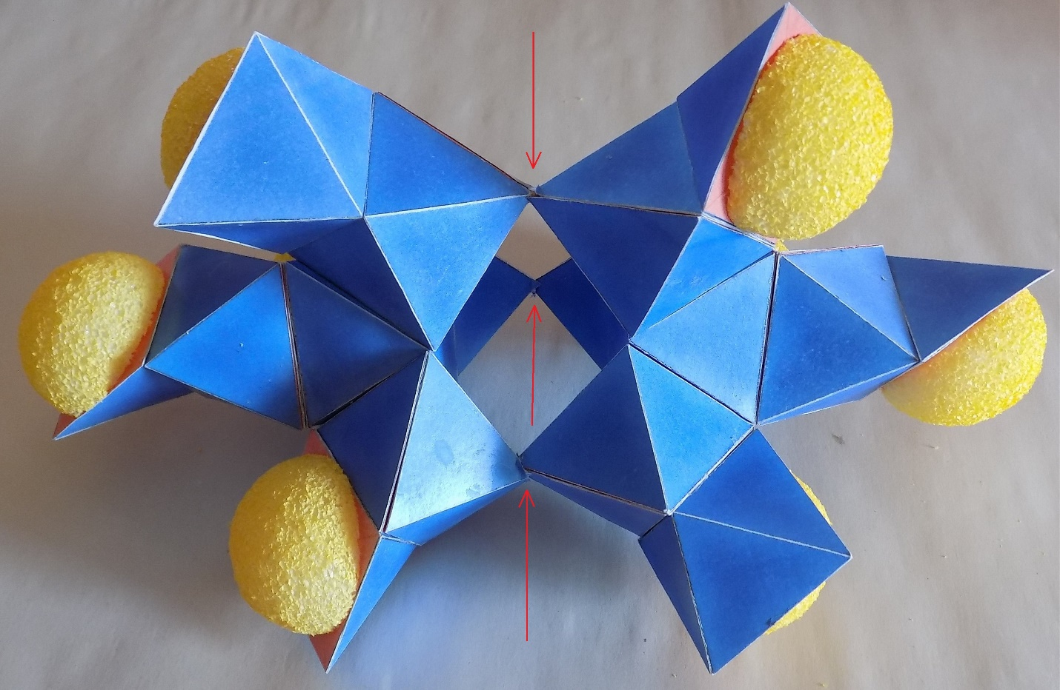

This geometry shows that breaking the triple bonds in a chemical reaction would be very difficult. The ends of the molecule, as portrayed by the open base protons emitting vaporized elysons, would be highly repulsive to another atom. If an impacting atom were to come from the side, where no repulsion is present, it would have to break all three bonds with one impact. Perhaps only a high velocity neutron could achieve this breakage.
On the planet Venus the atmospheric temperature is 864ºF, but N₂ is still stable. When the first atomic bomb was detonated, scientists were worried that the explosion would break apart N₂ molecules and cause nitrogen to combine with oxygen to make nitric oxides. It did not happen.
Another picture of the nitrogen molecule is shown below:
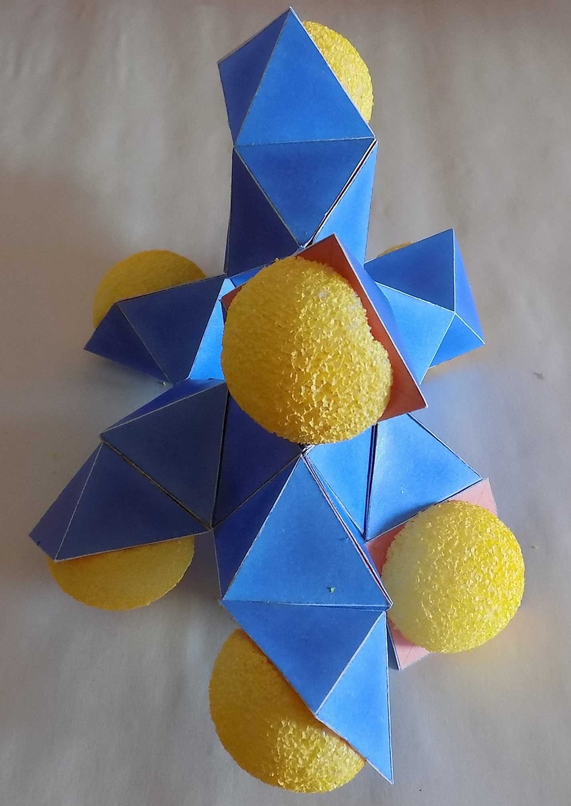
MAGNETISM
Magnetism is always associated with metallic crystal. The most common are iron, nickel and cobalt. Aluminum within a crystal structure of the above other metals can also form a strong magnet.
It is proposed here that magnetism is simply the linearization of the gravitation flux. The molecular, crystal structure of the magnetic material causes gravitons to move together in a manner similar to laser light. The flow of gravitons through the magnet is bidirectional. Once gravitons leave the magnet, they become disoriented due to collisions with atoms and molecules which are not magnetic. This includes air.
If a magnet was energized in space – a near total vacuum – the magnetic, or graviton flow, may not become scattered. If so, the “beam” of magnetism (that is, gravitons) would travel at approximately 20 billion times the speed of light. Since gravitons are not a wave phenomenon, there would be no spreading out and weakening of the collinear graviton flow.
This brings up the possibility that a magnetic beam could be sent from one solar system to another solar system that is 1,000 light years away. Time for travel would be a matter of 15 to 20 seconds. If the magnetic beam was turned on and off, it could be used like Morse code. Therefore, the SETI scientists, who listen for radio waves, may be studying the wrong phenomenon when looking for communication by sentient beings.
Magnetism is associated with electric current. With a magnet focusing a linear stream of gravitons impacting on an electrical wire, the liquid elysons on the atomic crystals of the metallic wire would be preferentially pushed in a certain direction. The result would be an electrical flow along the wire.

ELECTRICITY
We associate the actual flow of electricity as being a fluid passing through or over some kind of structure. This paper does not agree that electrons, presumably orbiting nuclei, constitute the flow of electricity. Instead it has been proposed that liquefied elysons from the light carrying medium are the actual constituents of fluid electricity.
The photographs of paper models below show a very simplified example of a carbon filament through which electricity flows.
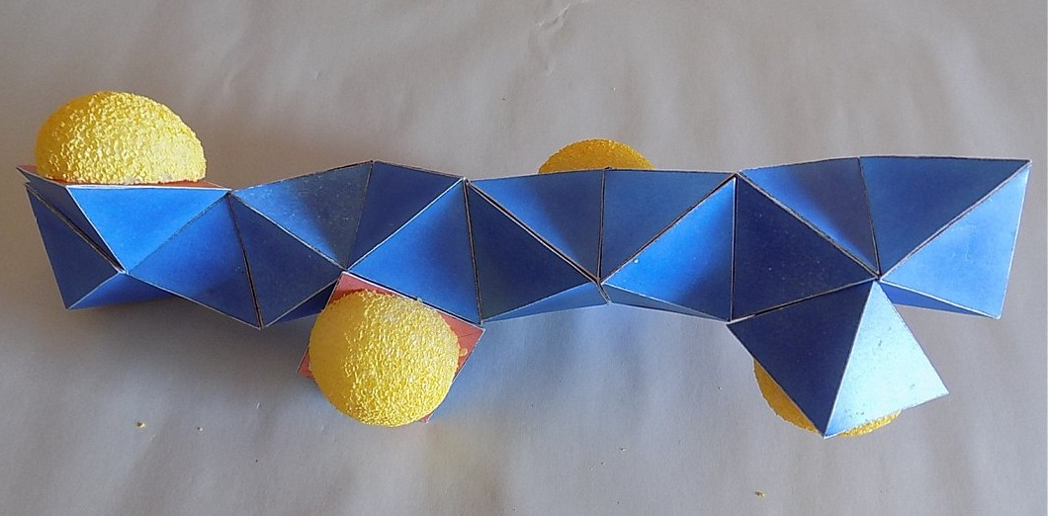

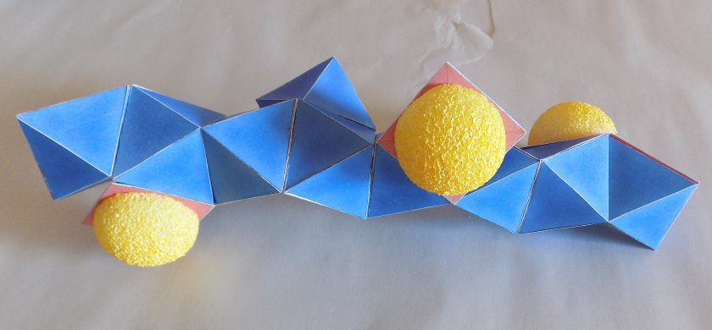
The flow of the liquid elysons would pass over the surface of the protons. Given that the flow of electricity is substantial, there will be overflow into the open cavities of the hollow, pyramidal protons. The half yellow spheres represent liquid elysons being vaporized by the incoming graviton flux. Once liquid elysons have poured over the edge of the open, hollow protons, their only way out is to be vaporized. Thus, we see light. One must keep in mind that “up” and “down” are entirely determined by the proton geometry. The graviton flux travels in every direction and does not have an “up” and “down”.
The overflow and vaporization of liquid elysons is how the electrical “power” is consumed.
An electric motor does work but it also gives off heat, which is another example of liquid elysons being vaporized and therefore “consumed”. If your home has electrical heating, then liquid elysons are being vaporized at the electromagnetic frequency of heat. It is not the protons in air molecules that are increasing in temperature. It is the vaporous light carrying medium that is rising in temperature.

THE GREAT PYRAMID
The Great Pyramid at Giza has remained a complete mystery in modern times. When was it built? Who built it? Above all else, what is it? Conventional Egyptology declares that all pyramids were tombs for the pharaohs.
The sophistication, required technology and cost of the Great Pyramid conflict with the thought that it is simply a tomb. This level of effort for a burial place stretches common sense to the breaking point.
To quote Alan Alford (The Phoenix Solution) “Is it so crazy to suggest that the unique design of the Great Pyramid was a legacy from an earlier, more advanced culture? In my view, it is certainly much less crazy than continuing to believe that the Pyramid was constructed as a tomb for a dead king, and that he built this totally over-engineered and revolutionary wonder of the world with absolute perfection at the first attempt.”
His statement was the genesis of this chapter.
It is proposed here that the Great Pyramid was a nuclear fission production mill, and it was a technical success. It did not create energy but packaged energy within artificially created isotopes of plutonium. This hypothesis is not fantastic in the sense that it would be a physical impossibility but is fantastic only in the fact that it upsets the conventional history of man. In our current history, the awareness and confirmation of the release of a vast amount of energy from nuclear fission was realized in the late 1930s.
If a sufficient amount of uranium ore is placed in the correct geometry with a “moderator”, such as graphite or water, the neutrons released by U-235 can be used to create Plutonium 239 from U-238. Pu-239 is fissionable material and is chemically distinct from uranium. It can be chemically separated from reacted uranium ore by solvent extraction. This procedure is immensely easier and simpler than U-235 purification.
The natural fission of U-235 releases two to three neutrons which have high velocity. If these neutrons are allowed to pass through graphite or water, collisions with the nuclei lower the speed of the neutrons and reflect them back into the uranium ore where they can cause more fission of U-235 and can be absorbed by U-238 nuclei. This absorption creates Pu-239. The Pu-239 can also undergo fission from returning neutrons, which releases two to three neutrons. These neutrons can be reflected back into the uranium ore to create even more plutonium. The capacity for a rapid geometric growth in plutonium is “unlimited” and there can be a runaway reaction if the system is not carefully controlled. Control rods, which absorb neutrons, can be inserted into the reactor core to rapidly reduce the population of neutrons. This control material not only can prevent a runaway reaction but it can be used to bring the entire fission process to a halt. Alternatively, if the graphite or water is suddenly removed from close proximity to the uranium ore, the fission process will also come to a halt.
If a nuclear core is run improperly and undergoes a runaway reaction, the energy release will physically blow the reactor apart and the runaway reaction will stop. Such an event does not measure up to a fission bomb detonation by several orders of magnitude. It does constitute a conventional size thermal explosion and creates a radioactive mess. This happened at Chernobyl, which used graphite.
If a nuclear core that was set up to create fissionable grade plutonium is run too long, other isotopes of plutonium will be created. If their concentration reaches 7% or more of all plutonium, then the plutonium cannot be used for fission. The other plutonium isotopes interfere with the growth in neutron population being created by Pu-239 and the material cannot go supercritical. However, this mix of plutonium isotopes can be used to produce energy for civilized use.
This fact is the technical and economic basis for breeder reactors. Such a reactor produces an amount of useful energy and also creates more nuclear fuel than it consumes. Through the breeding process, the amount of useful nuclear fuel within U-238 ore can be increased almost one hundred times. This process constitutes a highly successful venture, if properly designed.
In actuality, plutonium is inanimate; does not possess the capacity of morality, and cannot make moral decisions. Its behavior is completely predictable. Commercial nuclear reactors are officially powered by uranium. In reality, one third of the energy production comes from plutonium, because it is made and consumed in the reactor core. Although graphite can be used as a moderator, water can also be used as a moderator. In addition, a flow through of water around the reactor can take away the released energy in the form of hot water or steam. This limits the temperature of the reactor and prevents a “meltdown”.

The history of the ancient Egyptian civilization was recorded in hieroglyphics cut into stone. Even when “paint” was used on the stone, the symbolization was first cut into the stone. None of these stone records attribute the Great Pyramid to a pharaoh or anyone else. There is no record of when it was built, why was it built or what its purpose was. There are no symbols cut into the stone of the Great Pyramid. The only symbolism found was “discovered” by Howard Vyse in 1837 in a recess above the Kings Chamber which was not accessible until Vyse blew open a path to it with black powder. It consisted of only pigment and is considered highly suspect. The symbols were completely out of character with how and where ancient hieroglyphics were done. Therefore, Vyse’s claim that Khufu built the Great Pyramid is in extreme doubt.
There is no artistic expression to the pyramid. To quote Alan Alford “the builders of the Great Pyramid seem to have been concerned only with accuracy and stark functionality.” Nothing was found inside the pyramid, which related it to any pharaoh by attribution or by possessions. The sarcophagus bears no resemblance to any coffin for a pharaoh.

The accuracy and the precision of the Great Pyramid both at the level of individual blocks, and as a whole, are without precedent. Modern day engineers are at a loss as to how it was done. The tools described as necessary for the cutting of stone and the positioning of stone have never been found nor are they referred to in ancient records. The precise cutting of granite, including precise interior surfaces, requires complex, powered machinery with industrial diamond bits. The raising and exact positioning of granite blocks as heavy as 80 tons to heights as much as 300 feet above grade would require huge, powerful cranes – according to current industrial practice. It is simply beyond the capacity of wooden structures and human laborers. The entire positioning of the whole structure is so accurate that modern, surveying, optical equipment would seem to be an absolute necessity.
The interior fit of stones in the Kings Chamber and Great Gallery appears to be almost watertight. A mortar was used which had a higher hardness than the stones it was used on. The mortar was analyzed for elemental content but it has not been duplicated.

Functional Nature of The Great Pyramid
A useful illustration of the interior geometry of the Great Pyramid is given below:

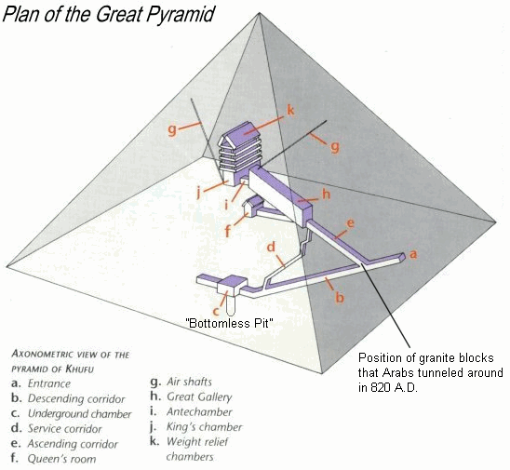
A fundamental axiom of engineering is that form follows function. An engineered system must be fabricated and assembled in accordance to the functions it must perform. Variance from this axiom, for the sake of economy, as an example, will result in failure of function. A subsequent corollary is that a system, which is operated, will wear out. A stronger design will give a longer life. The claim that a process plant has been over engineered will make a startup engineer’s blood boil. Any engineer assigned to operating a process plant will immediately embrace the philosophy of “build it once, build it right”.
The Great Pyramid was built to last as a process plant for a very long time.
The heart of the pyramid is the Kings Chamber and the heart of that is the sarcophagus. This was also the heart of the process. The uranium oxide would have been fitted into the sarcophagus. It may have been put in as bricks or pellets or even in granular form. Depending on the oxide used, the density of uranium oxide is 9 to 11 times that of water. It has no buoyancy at all.

At this point, a review of the types of radiation is in order. Alpha radiation is emitted by uranium and plutonium isotopes. This is the natural decay process for these isotopes and is low energy. It consists of a helium nucleus; it has large mass and low velocity. This helium nucleus very quickly collides with any nucleus around. Six inches of air or a very thin layer of paper will absorb alpha radiation. Beta radiation is an electron with significantly higher energy than alpha. It takes several inches of solid, non-metallic material, or a thin layer of metal, to absorb this radiation. Gamma radiation is very high energy and has no association with any particular particle. It is quite penetrating and is absorbed by very dense material such as lead or gold, or about 15 feet of stone. Under the act of fission, in which a nucleus splits apart into two lighter nuclei, a few neutrons are also released. These neutrons possess high velocity and very high energy. They will pass through metal or stone very well. The materials, which interact with them best, are substances containing a lot of hydrogen, such as water or oil. The protection for workers in a plutonium extraction plant, who are working with fissionable material, consists of alternating layers of leaded glass and clear oil. The leaded glass absorbs gamma radiation and the oil slows down and reflects neutrons.
The sarcophagus was fabricated from a very hard granite, even harder and denser than the rest of the granite used to build the Kings Chamber. This fact is a very significant signature of its function. The interior dimensions of the sarcophagus are very precise. This is consistent with maintaining a very exact amount and geometry of the uranium oxide. The outside of the sarcophagus was rough cut. This reflects the fact that the outside surface of the granite is quite unimportant to the fission process. The granite must be able to withstand the high temperature and radiation emitted by the fission uranium oxide. It has to survive the damage from radiation for a very long time. It must allow passage of most of the neutrons, which it does. Color photographs show that this granite sarcophagus has undergone radiation and heat damage in a very gradual manner over a very long time. Its appearance is very reminiscent of metals and minerals, which experienced long term radiation in the canyons of the plutonium mills at Hanford. The damage, or “wear”, indicates an operating time of many years.
The Kings Chamber is made of very large blocks of granite. The inner surface of the granite bears a striking resemblance to interior walls of a plutonium mill. Once again, there is the appearance of long-term exposure to radiation and heat. The floor and walls of the chamber appear to be well sealed. This is consistent with the Kings Chamber being flooded with water.
The photograph below is taken from Alan Alford’s book “The Phoenix Solution”. Alan is kneeling at the northeast corner of the sarcophagus. There are three vital clues shown in this picture:

- Unlike other, very smooth granite blocks within the pyramid, the granite blocks in the King’s Chamber are well etched and blackened.
- Near the southwest corner there is a vertical, plaster patch on an area where apparently the granite block broke open. It has the appearance of calcium sulfate dehydrate, which is an excellent and very stable sealant for very hot water.
- The sarcophagus shows wear throughout. However, the southeast corner of this granite box shows the most extreme wear. This position is nearest the cold water entrance to the chamber. Cold water causes a much higher reflection of neutrons than hot water, so the highest back and forth traffic of neutrons was right here. This results in the greatest wear down of granite crystal. The cold water is about 5% more dense than the boiling hot water. Neutrons are said to have no electrical charge and therefore would only be reflected by water nuclei. According to the Rutherford – Bohr – Pauling atom model, the nucleus occupies only one hundred thousandth of the volume of an atom. If this were true, then a 5% difference in water density would not have the effect of increasing neutron reflection back into the granite box. Since the neutron reflection is significantly increased by water density, the nuclei of the water molecule must occupy a considerable amount of the water molecule. That is one of the claims of this paper.
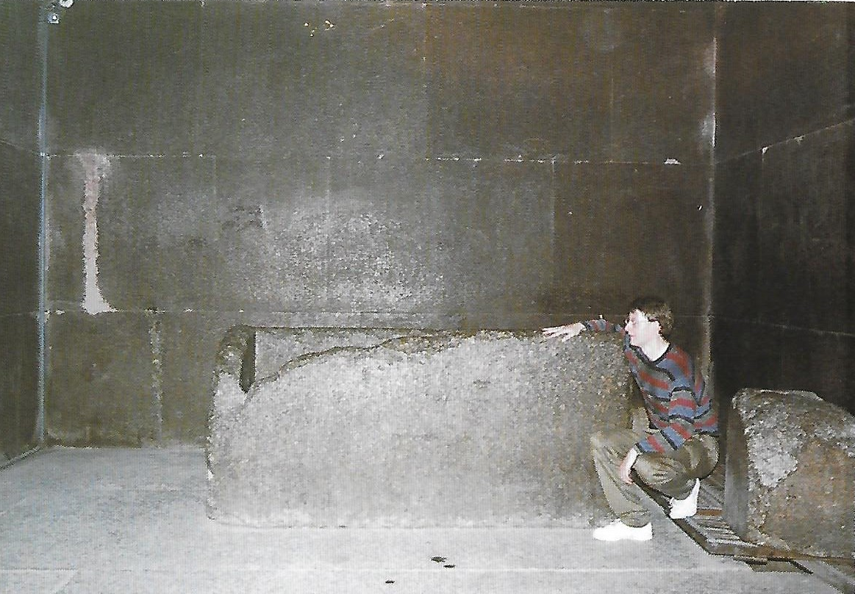
The water in the chamber has multiple roles. It is the medium, which slows down neutrons and reflects them back into the uranium oxide pile. It is also the mechanism for removing heat from the chamber. The south “air shaft” from the outside to the chamber would have been a pipe for continuously adding cold water to the system. This shaft is 8 inches by 12 inches by 175 feet in length. After a short horizontal run from the Kings Chamber, it rises at a 45 degree angle to the outside of the pyramid. Hydraulic calculations for water indicate that the flow would vary from 5,900 to 8,400 gallons per minute, depending on the back pressure of the water and steam in the Kings Chamber. The water would have flowed out through the entrance to the Kings Chamber down into the Great Gallery (This entrance was highly constricted by three granite blocks.) The exiting water would have carried away radioactive, soluble isotopes such as Cesium-137 and Strontium-90. A second “air shaft” connecting the north wall of the chamber to the outside would have been a vent, which released steam and non-condensable gases. This shaft is 5 inches by 7 inches by 235 feet in length. After about 10 feet of horizontal run, it rises at a 31 degree angle. Calculations for compressible flow give the shaft a steam flow rate of from 3 to 8 pounds per second, depending on the Kings Chamber pressure.
The final role of water is very interesting and quite ingenious. The reflection of neutrons by the water back into the uranium pile must have a careful, narrow control to it. The mean free path of a neutron in water is about one foot. A neutron must undergo about 6 to 7 collisions in the water to finally reach the appropriate speed and be reflected back towards the nuclear bed. If not enough neutrons are reflected, the fission reaction will die down. If too many neutrons are reflected back, the reaction will begin to grow rapidly, producing too much energy. However, when the energy production goes up, the water heats up and begins to form steam. Steam occupies about 1,000 times as much volume as water and it would progressively occupy more of the volume of the Kings Chamber as more energy was released. For all practical purposes, steam does not reflect neutrons back to the uranium bed because the nuclei of steam molecules are very far apart. This fact stops a runaway reaction because more and more of the geometry around the reactor core becomes steam instead of water. This design is a passive and very stable system for controlling the rate of fission in the sarcophagus. When operating, the Kings Chamber would have always had some volume of steam in the upper portion. This volume would have grown and shrunk in response to the fission rate, keeping it in control.
Based on the limits of flow for water and steam, and based on maximizing the removal of heat via water and steam, about 570 million British Thermal Units per hour could be removed from the Kings Chamber. It is beyond the ability of the author to relate this energy removal to the breeding rate of plutonium. Hopefully, nuclear engineers can bring definition to this hypothesized purpose of the Great Pyramid.
We now come to an example of the real purpose of geometry. An overall view of the interior structure of the pyramid shows that the entrance, the descending passage, the ascending passage and the Great Gallery are not at the east-west center of the pyramid but about 24 feet east of center. The Kings Chamber is not in north-south alignment with the descending passage, the ascending passage and the Great Gallery. It is offset to the west. Furthermore, the sarcophagus is located in the western end of this chamber. From the viewpoint of aesthetics, it is “ugly” and out of balance. The sarcophagus, which is the source of highest temperature and pressure, is in the very center of the pyramid. The processing of a uranium core in the sarcophagus is halted by stopping the flow of water down the “air shaft” to the Kings Chamber. The water within the chamber heats rapidly; some of it becomes steam; and most of the water is blown out through the Antechamber into the Great Gallery. Because the energy being dealt with is enormous, it is very important that the water is quickly removed from the chamber to a location that is geometrically remote from the sarcophagus. This rapidly stops the reflection of neutrons into the uranium oxide. Also, the water that is moving rapidly and forcefully through the exit, is as far from the sarcophagus as practical. This internal geometry is a requirement of physics; it is not symbolism or a “message”.
The complex structure above the Kings Chamber is a sort of “shock absorber”. The monstrous blocks of granite, with air pockets between them, absorb most of the effect of the explosive steam at the end of a batch run of uranium oxide. In fact, the granite beams could crack all the way through and still remain in place. The much smaller and much weaker blocks of limestone, that make up most of the pyramid, could not be used for the ceiling of the Kings Chamber.
Within the Antechamber, which is between the Kings Chamber and the Great Gallery, three blocks of granite restricted the flow of water from the chamber to the gallery and maintained a water level in the Kings Chamber.
The Great Gallery serves multiple functions. First, it is a large volume that allows separation of water and steam. The upper end of the gallery has an air shaft leading to the outside. This enables the escape of non-condensable gases and steam. The lower end of the gallery spills to the upper end of the Service Shaft, which drops all the way down to the Underground Chamber. The floor of the gallery has a sunken trench running down the middle. The outflow of water would pass through in this trench during normal operations. The trench is surrounded on both sides with higher “walkways” which have slots cut into them at regular intervals. These slots probably were occupied by “stays”, which allowed the progressive lowering and raising of new and spent uranium ore along the Great Gallery. There are two grooves in the walls, which extend the entire distance of the gallery. These grooves would very likely be the “runways” for an overhead hoist. The hoist could maneuver loads of spent reactor core from the exit of the Kings Chamber to the open surface outside the tunnel to the Queens Chamber. With the vent at its upper end and with its connection to the Ascending Corridor and the Entrance, the Great Gallery would have drawn air up through it, which would be countercurrent to the flow of radioactive, hot water. This would sweep radioactive gases up through the vent and the air would have been breathable. It has been noted that the perfect fit of stone in the Great Gallery makes it almost airtight. The stone from the Antechamber to the trench in the Great Gallery shows considerable wear - apparently from water.
Spent reactor cores from Hanford reactors were transferred by armored train to plutonium separation mills where they were placed in a very long canyons. The spent cores would advance along a canyon over a period of weeks before being chemically processed. This gave time for short-lived isotopes to die down, which greatly reduces the gamma and beta radiation. These two types of radiation are quite penetrating and quickly harmful to human life. One can envision a “train” of these spent cores slowly progressing down the Great Gallery.
The Queens Chamber is probably the laboratory, which chemically extracts and purifies the various plutonium oxides from all other waste. It is noteworthy that this chamber is placed quite a distance from the lower end of the Great Gallery. This distance would give added protection to workers in the chamber. The two shafts, which leave the Queens Chamber, are of unknown purpose but they were definitely “pipes” which conveyed materials. Waste separated from plutonium would have been walked back to the Well Shaft and dumped down it. The wearing of gold facemasks, etc, would have been excellent protection from the radiation in the Queens Chamber.
The products of fission, such as Cesium-137 and Strontium-90, are quite soluble, whereas uranium and plutonium oxides are extremely insoluble. A constant pass through of water in the Kings Chamber would have flushed these short-lived, radioactive isotopes all the way to the Underground Chamber via the Great Gallery trench and the Service Corridor.
The Service Corridor is small and winding and mostly vertical. Human travel through it would be very difficult and pointless, since the Ascending and Descending Corridors are available. It shows extreme erosion. Why would a “pharaoh’s tomb” pyramid have extreme erosion in a shaft isolated from the outside world? Even floods would not have reached this corridor. The obvious answer is water erosion over a very long time. Part way down this shaft is the Grotto. This position is just barely below the surface of the prepared bedrock base for the pyramid. This chamber served some function.
The Underground Chamber has an interesting geometry. The eastern half is about six feet below the termination of the Descending Corridor. In the center of this eastern basin is the “bottomless pit”, so called because the earliest discoverers could not find a bottom. The western area is about 8 feet higher and it has five bench like protrusions and two depressions. A walkway is cut from the eastern basin up into the western chamber, halfway between the two largest “benches”. Overall, the ceiling is about 11 feet above the floor.
To the south is a horizontal chamber that is 30 inches wide by 30 inches tall by 53 feet long. This last excavation could not have been dug with hand tools. The material is bedrock and there is not enough room to swing a tool such as a pick, especially with the worker lying on his stomach or his back. Powered machinery seems to be the only reasonable answer.
The purpose of the Underground Chamber was twofold. The first purpose was to drill a hole down through the bedrock to a sand layer below. This depth might have been one hundred to several hundred feet. The radioactive water coming from the Kings Chamber would finally go down the hole and disperse into the sand layer. This is a routine methodology in secondary recovery oil fields, where hot water or steam or gas is injected into a sand layer. The sand layer would have accepted and retarded the migration of radioactive isotopes – long enough for them to decay to trace levels.
The second purpose was hydroelectric power. The entire floor of the Underground Chamber bears an amazing resemblance to the support structure for a water driven turbine electric generator. The water wheel would have extended out from the western chamber into the eastern chamber. The water coming down the Descending Corridor would have shot across the water wheel. The benches on the western chamber floor would have supported the rest of the machinery, including the generator. There is even a support and depression for an oil cooling system. The stairway cut into the western floor gave access under and behind the water wheel to where the shaft and couplings would reside.
Based on the projected water flow from the Kings Chamber, the dynamic head of the water dropping almost 300 feet, and a turbine efficiency of 78%, the produced electrical power would have been from about 29 kilowatts to 41 kilowatts. This is an adequate amount of power to provide lighting within the pyramid and to run modest electrical machinery in the Queens Chamber. The chemical separation of plutonium from uranium involves the use of electrical power, just as it was done at Hanford, Washington. This generation and use of electricity would have been entirely within the Great Pyramid, hidden from outsiders.
The floors and well hole are strongly eroded. The obvious eroding agent is water. And the entrance to the Descending Corridor is well above the landscape, so natural flooding could not be the cause.
The Grotto, which is just off the Service Corridor, would have been a logical position for an electrical distribution point and for changes in voltage.

Shutting Down the Great Pyramid
The wear seen in various parts of the pyramid’s internals suggests an operating life of a few hundred years. The process may have been halted because enough product had been made or the wearing down made the process unreliable and dangerous. This is hinted at by the erosion of one corner of the sarcophagus. There are significant clues that the system was purposely put out of commission and sealed. The three granite blocks in the Antechamber to the Kings Chamber were apparently removed and then used to block the low end of the Ascending Corridor. The slots and grooves in the Great Gallery had equipment removed from them. The Queens Chamber was obviously stripped of equipment. The creator of the pyramid would have told the Egyptians of the horrible death that lay inside and commanded them to not attempt entry.

The Meidum Pyramid
Ancient Egyptian history does attribute the building of later pyramids to the pharaoh Sneferu. His designs appear to be based on the Second Pyramid at Giza and upon verbal information passed down through centuries about the Great Pyramid. They did not have access to the internals of the Great Pyramid. In fact, the first time internal access was achieved was in about 820 A.D. by Arabs. The first pyramid by Sneferu was the Meidum Pyramid. This pyramid’s internal structure does have a descent from the outside to the Kings Chamber of about 70 feet. Therefore, the entire internal structure could have been flooded with water. However, there was no provision for passing water through the Kings Chamber so as to remove heat. Apparently, as will be seen, the pharaoh had the knowledge of using yellow cake (uranium oxide), using water and making the material near the box of uranium oxide be granite. They were aware that the process would lead to “fabulous” energy and consequently wealth. However, they had no conceptual understanding of the process of creating plutonium.
Color photographs of the Meidum Pyramid’s internal structure are very revealing. The Descending Corridor has precise geometry to begin with. After some distance, the surfaces of the corridor become increasingly irregular, rounded and larger than the “good” corridor. The Queens Chamber is extremely irregular in shape. In the Kings Chamber, the corbelling in the vertical ceiling is very rough and the floor is quite uneven. Standard Egyptology states that the workers gave up on doing a good job on the internal structure. But this work would have been the first five percent of the effort of making the entire pyramid. If the workers “gave up”, why was the remaining 95% completed?
The evidence and logic point to another cause for the rough interior and the collapse of much of the exterior of this pyramid. A sarcophagus would have resided in the Kings Chamber and it would have been loaded with uranium oxide. The entire interior would have been flooded with water. Because of no pass through of water and because of the very high and very narrow shape of the Kings Chamber, the nuclear pile would have reached criticality and then become a runaway reaction. Once beyond the initiation of criticality, the runaway takes only seconds. There would have been a rapidly growing steam explosion and the entire interior would have behaved like a gigantic shotgun blast. Interior surfaces would have been blasted out. The shockwave would have destabilized the whole pyramid and brought down the thousands of smaller exterior blocks. One can be sure that the Egyptians steered clear of this disaster.
The Meidum disaster was not from stupidity. It was from ignorance.

The Bent Pyramid
The Bent Pyramid is the “learning curve” pyramid. There are two entire interior systems. The first one was built of limestone and down into bedrock which was probably as soft as limestone. The interior layout is quite similar to that of the Meidum Pyramid. However, there are two vertical shafts adjacent to the Kings Chamber. They are not ornamental but appear functional in a technical sense. They might have been intended as relief chambers if an explosion occurred once again.
As in the Meidum Pyramid, the Descending Corridor begins with good geometry and then progressively degrades into a larger, irregular, round tunnel. The antechamber is distorted and the corbelled ceiling is very rough. The Kings Chamber also has a crude appearance. The two vertical shafts, were found full of rubble. Once again, there is the signature of a runaway reaction and consequent steam explosion. There was no capacity for passing water through the Kings Chamber and this chamber had the wrong geometry. The lower exterior of the pyramid held up well; there was no major collapse.
It is very probable that the pyramid was built only about half way up and then the uranium oxide was placed in the sarcophagus; water was loaded and the system was tested. The explosion was not as severe as it was with the Meidum Pyramid. The pharaoh Sneferu was probably convinced that he was approaching success in acquiring great energy but was still ignorant of vital details.
From on top of the uncompleted Bent Pyramid, a tunnel was dug down and through to the original Kings Chamber. The Egyptians probably examined the remains and damage to the sarcophagus and Kings Chamber to see what had happened.
They proceeded to build a second interior and the rest of the pyramid. The new Descending Corridor had two substantial portcullises built into it to isolate the Kings Chamber. One portcullis was positioned between the new Kings Chamber and the tunnel to the old Kings Chamber. Surprisingly, this portcullis was left in an open position. The other portcullis between the inner portcullis and the new Descending Corridor was kept closed. Beyond that the new descending corridor was sealed shut. It was prepared so that another explosion would pass out through the old interior system. The second Kings Chamber also shows damage to the corbelled ceiling and the floor. Undoubtedly another nuclear runaway reaction and steam explosion happened but it did exit through the old interior.
The Egyptians were making progress but still had no conceptual understanding of the nuclear reaction. They were attempting to duplicate the “mystery” of the Great Pyramid and one cannot fault them for trying.

The Red Pyramid
The design and construction of this pyramid reflects a dead serious and valiant attempt by the ancient Egyptians. They did not dig into bedrock but chose to build the interior structure with granite. They chose a distinctly lower slope for the pyramid. They built three large chambers with corbelled ceilings – each of them narrow and tall. All of this is granite! The mass of stone above this interior was more substantial than it was with the previous pyramids. There is an excellent chance that the use of granite around and above the interior structure is beyond what can be observed. There is no question that the structure was superior to the Meidum Pyramid and the Bent Pyramid. If only they had understood the concept of the nuclear reaction and the vital importance of geometry and pass through water!
Again, the Kings Chamber shows heavy damage to the floor and its exit corridor exhibits a blast out effect. Considering the weight of the pyramid and the strength of the corbelled ceiling in the Kings Chamber, the steam blast probably blew down into the floor besides exiting out the granite, descending corridor.
One must salute these ancient Egyptians. They did their best with the knowledge they had. After failures with three pyramids in succession, this type of endeavor was probably abandoned. This abandonment may have been congruent with the death of the pharaoh who led this cause. If ancient Egyptian records are correct, Sneferu’s son, Khufu, then went north to Giza with a great deal of frustration and anger with the failure of his father’s pyramids

Conclusion
Every process step for breeding plutonium, controlling the nuclear reactor, separating the plutonium from other radioactive material, and disposing of radioactive waste, is taken care of by the internal structure of the Great Pyramid. Even the production of internal electrical power is accounted for.
But why build the Great Pyramid to produce plutonium? This is where the Great Flood enters the picture. The Bible is a semi-historical book. When the Bible was assembled by the order of the emperor Constantine in the fourth century AD, a number of books were banned from the newly assembled Bible. In particular, the books of Enoch were left out. A translation of the Enoch books claims that “God” commissioned Enoch to build the Great Pyramid. Presumably, Enoch was given directions on how to build the Great Pyramid. Since the construction of the pyramid requires technology more advanced than what we have now, the civilization on Earth must have been highly advanced. Very likely, they had the ability to travel in space and had telescopes that could peer very accurately far out into space – in particular, beyond our solar system. They may have observed a wandering planet that would enter our solar system and pass close to Earth. Such a planet would have a tidal effect upon the Earth the same way as the Moon does. However, the tidal effect would have been a great many times stronger than that caused by the Moon. Keep in mind that the Earth rotates, so such a tidal surge would advance across the Earth at one thousand miles per hour at our equator. This observation and calculation would have been accomplished several centuries before the planet would arrive. There would have been considerable time to construct the Great Pyramid and other pyramids at Giza, Egypt. The structure of these pyramids was designed to survive a repetitive worldwide flood. Enoch was the great grandfather of Noah. According to the Old Testament, these generations of men lived to be several centuries old. This would mean that Noah was given the word to build an ark perhaps a few years before the arrival of the “wandering” planet and the resultant Great Flood.

The energy “spark plug” for restoring civilization on Earth would have been the produced and stored away as plutonium created in the Great Pyramid. Presumably, a few persons would have gone into space to avoid the world wide flood and waited until it was over. On returning to Earth, the Great Pyramid could have been cleaned out and restarted.

Methodologies For Scientific Proof of Nuclear Fission in The Great Pyramid

Short Lived Isotopes
The primary decay chains for thorium, uranium, neptunium, etc, result in the final production of several helium nuclei and lead, or something close to lead. Fission, however, produces lighter nuclei and the highest probability products are Cesium-137 and Strontium-90. The cesium will decay to Barium-137 and the strontium will decay to Zirconium-90. These end products are stable nuclei.
If the internals of the Great Pyramid were a nuclear breeder system, then there was a sizable wash through of water, which went to the Bottom Chamber. From there the water would have descended to an underground sand layer. Assuming retention of the uranium and plutonium oxides, the major, soluble, radioactive isotopes are Cesium-137 and Strontium-90. Because they have half-lives of 30 years and 28 years, respectively, they would no longer be detectable.
However, Barium-137 is very insoluble as barium carbonate, and presumably the bedrock in the Bottom Chamber is limestone or close to it. Some of the barium – as an ion – would have exchanged with the calcium in the limestone, producing insoluble barium carbonate. The discolored surface of the bedrock in the Bottom Chamber would have barium carbonate and this surface material is a prime specimen for sampling. The interior of the limestone should not have more than about one part per million of barium, because barium is quite toxic as an ion and presumably the limestone came from living matter.
Zirconium would behave in a similar manner by depositing as zirconium oxide hydroxide, ZrO(OH)₂. This compound is extremely insoluble, even in mildly acidic water. A sample of discolored surface material from the bedrock in the Bottom Chamber would be ideal for analysis. The interior of the limestone should not contain more than several parts per billion of zirconium, because it is not a part of living matter and the salt, zirconium carbonate, is fairly soluble and would not have precipitated.
These samples would be digested in acid and analyzed for barium and zirconium. The presence of both or either would be a positive indicator, but not proof, of nuclear fission.
If barium were present, it would have to go through isotopic analysis to determine the spread of barium isotopes. Naturally occurring barium will be 71.66% Barium-138 and 11.32% Barium-137, with lesser portions of other barium isotopes. A scraping of the limestone would probably result in about 50% surface material and 50% interior material. If analysis of barium isotopes gave a Barium-137 percentage higher than twice the natural 11.32%, that would be very strong evidence of nuclear fission.
If zirconium were present, it would also have to go through isotopic analysis. In natural zirconium, 51.46% is Zirconium-90. Again, a scraping would probably be 50% surface material and 50% interior material. If the measured Zirconium-90 was higher than 60%, then this would also be powerful evidence of nuclear fission.
Nile river water should have not more than one part per million of barium and only a few parts per billion of zirconium.
A baseline comparison for barium and zirconium concentration and isotopic spread would also have to be done with a sample from the interior of the bedrock. This sample and its analysis would either support or fail to support the claim of nuclear fission.

Long Lived Light Isotopes
A nuclear core, which is brought up to criticality, establishes a high flux of neutrons. What the neutrons do is a probability distribution, much like a bell curve. A fraction of them will not return to the uranium oxide formation but will collide and be absorbed by other species. For instance, some of them will create deuterium oxide in the water; others will interact with nuclei in granite, causing some of them to become radioactive. The most probable long-lived, radioactive nuclei in granite are Aluminum-26 and Calcium-41. The aluminum isotope has a half-life of 740,000 years and the calcium isotope has a half-life of 110,000 years. A piece of the granite sarcophagus would have the highest chance of possessing these isotopes. A sample of this granite would have to be examined for the known radiation types and frequencies of these two isotopes. Natural granite would not have any Aluminum-26 and Calcium-41 because their half-lives are far too short in comparison the age of the granite.
Samples from the granite floor, walls and ceiling would be far less likely to have radioactive species than the sarcophagus because the large volume of water in the Kings Chamber would have absorbed or reflected almost every neutron.

Long Lived Heavy Isotopes
Uranium and plutonium oxides are extremely insoluble and would not have dissolved in the water. However, traces of these compounds might be found on the surface of the granite in the Kings Chamber and on the surface of the limestone in the Great Gallery and the Queens Chamber. It is a very common technique for radiological workers to wipe surfaces with a slightly damp cloth and then check the cloth for radiation with a Geiger counter. This procedure must be done very carefully, and with the optimum sensor, because alpha radiation is very weak and does not penetrate. Once again, these isotopes have known frequencies for their radiation, so they could be identified.
The presence of these isotopes would not prove nuclear fission but would certainly prove that fissionable isotopes were in the Great Pyramid.
Natural granite will have traces of Uranium-235 and Uranium-238 within it. There should not be any plutonium. If the granite from the Kings Chamber was exposed to a neutron flux, some of the U-238 would have been transformed to plutonium isotopes. The presence of any plutonium would prove nuclear fission. A depletion of U-235 compared to U-238 would also demonstrate nuclear fission.
SECOND AND THIRD PYRAMID AT GIZA
The Second and Third Pyramids are located adjacent to the Great Pyramid at Giza and were operated in unison with the Great Pyramid.
Calculations for water flow and steam flow through the airshafts of the Great Pyramid system indicate a very modest level of plutonium production. (An attempt at a larger production rate would raise the pressure of the King’s Chamber high enough to stop all water flow.) Thus, if a civilization had two dozen space ships, the amount of plutonium produced could not be the primary fuel of “nuclear” space ships. This implies that polydeuterium, properly formulated, would be the primary fuel, with the plutonium acting as an igniter: a neutron source to initiate fission of the polydeuterium.
This brings us to the plutonium “buttons” produced in the Great Pyramid. These buttons must be kept separated from one another. If they were piled together, that would cause a criticality – a self-sustaining, high intensity, neutron flux. In other words, they would constitute a nuclear reactor that has been turned on. There would be no explosion but the neutron radiation would be lethal to any nearby person in less than a second. As is done today, the buttons would have been placed and immobilized in a large, mostly solid, box with guaranteed geometric separation between buttons. Such a box would be very heavy, on purpose, and would rest upon a wagon. Maneuvering the wagon would have been done by ropes with a considerable distance between persons and the box. In reality, the buttons would emit all types of radiation, because one cannot achieve absolutely pure Pu-239.
Let’s look at the internal geometry of the Second Pyramid:

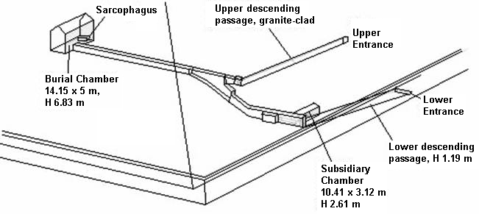
The fabrication of plutonium into useful forms for a nuclear module for an engine requires the following steps:
- Melting plutonium buttons.
- Pouring the melt into molds.
- Removing the plutonium from the molds.
- Machining the molded plutonium to achieve exact dimensions for plutonium parts.
- Tack welding plutonium parts together to form larger geometric structures.
In all of the above steps, there must be:
- Protection against criticalities.
- Protection of the workers from expected radiation.
- Protection against fires.
- Good geometric separation of the various steps so that any one accident would endanger as few steps of the process as possible.
- A means for workers to suit up before operations and a way to decontaminate after operations.
These steps and protections can be addressed by the internal geometry of the Second Pyramid:
- The Upper Entrance and Upper Descending Passage would allow for lowering the plutonium wagon into the Second Pyramid.
- The level corridor gives good distance to the Burial Chamber.
- The massive granite sarcophagus provides a stable, long lasting chamber for melting and casting plutonium. Limestone blocks would disintegrate, giving off carbon dioxide and leaving calcium oxide dust, under such high, radiant temperature.
- The cooled plutonium moldings would be brought by heavy wagon, out of the Burial Chamber, along the level corridor, down to the lower corridor, and then into the Subsidiary Chamber.
- The machining and tack welding of plutonium parts would have been done in the Subsidiary Chamber in a stretched out, assembly line fashion.
- The parts would have been loaded in a heavy wagon and taken out via the Upper Descending Passage and out the Upper Entrance.
- Workers would have entered and exited the pyramid by the Lower Entrance and Lower Descending Passage. This route would have been kept radiation free.
- The offset area close to the Subsidiary Chamber would be the logical position for protective suits and for decontamination.
There would have been blocks of carbon and the equivalent of plexiglass, to isolate the plutonium and to protect the workers. Significant amounts of these materials would have been in both chambers. Unfortunately, though these materials are excellent protection against neutron radiation, they are flammable. The American equivalent to this operation has had two accidental fires in the past half century. Both came very close to being disasters and one of the fires almost caused a criticality.
Conventional theory grants symbolism to the internal geometry, with even the idea that the slopes of the passageways have some numerical meaning or message. The nuclear speculation gives a utilitarian purpose to every passage, slope and chamber, and it is consistent in theme with the Great Pyramid speculation. The interior floors, walls and ceilings have a very drab, industrial appearance.
Let’s now view and consider the internal geometry of the Third Pyramid:

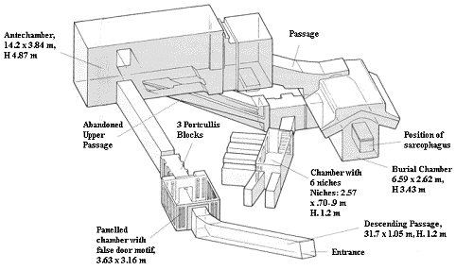
This interior is highly complex and very different from the other two pyramids. There are sloping passageways, which are consistent with moving a heavy wagon. Quite a number of chambers are present.
In our civilization, what has evolved in the design of complex apparatus over the past half century? It has been found that when there is failure of parts, by accidental damage or simply wearing out, that intricate repair work, in place, becomes far too time consuming or dangerous or even “impossible”. Consider the level of effort and risk of failure for astronauts to make repairs to such entities as the Hubble Telescope. Design has gravitated over to the concept of modules. When a particular piece of equipment has failed, we simply extract the entire module it is within and replace it with a fresh module. The entire process is quickly returned to service and the module with damage or worn out parts can be worked on separately or simply thrown away. Consider a nuclear fission thermal engine. The polydeuterium module would be a small portion of that engine and the plutonium igniter would be even smaller. It is proposed that such modules were loaded, and perhaps reloaded, with the plutonium igniter inside the Third Pyramid. The loading of these modules would have been conducted in the Burial Chamber. Fresh modules would have been stored in the Chamber with 6 Niches. Note that the niches are separated from one another by a moderate distance and limestone. They are also pointed away from the Burial Chamber, where a new or used module would be reassembled. Limestone does absorb neutrons to a moderate extent. It makes a great deal of sense to have identical nuclear modules and to have an inventory of them in a secure location.
When needed, a fresh nuclear module would be taken from a niche, loaded into a wagon in the small chamber adjacent to the Burial Chamber, brought up the first sloping passage, passed through the security portcullis, and on up and out the Descending Passage. A used module with spent fuel might have been brought to the Third Pyramid for reprocessing or it may have been abandoned. If such a module were brought to the pyramid, it might have been brought to the Antechamber and taken around the sloping passage where it could have had spent fuel removed in the small pit within that room. The emptied module may then have been taken down the sloping passage to the Burial Chamber for refitting with fresh fuel. The spent fuel could then have been taken to the Great Pyramid for processing. The spent fuel would have enough remaining plutonium (less than 30%) to boost the nuclear breeding in the Sarcophagus in the King’s Chamber. This recycling is only a possibility.
If the Giza pyramids were a nuclear production complex, they were completely disabled when the granite blocks within the King’s Antechamber of the Great Pyramid were moved to the bottom of the Ascending Corridor. The blocks remain there to this day. History states that the Arabs tunneled their way around these blocks in 820 AD. This digging was 20 to 30 feet in distance. Prior to that, there is no positive evidence of any intrusion into the upper portion of the Great Pyramid. It is extremely doubtful that any pharaoh ever had access to the Ascending Corridor, the Great Gallery, the Queen’s Room or the King’s Chamber of the Great Pyramid. Some writers have claimed that the Service Corridor was dug by the Pharaoh Khufu’s men to either gain access to the upper portions of the pyramid or to escape from these upper portions after they placed the granite blocks at the bottom end of the Ascending Corridor. The narrowness, complexity and vertical length of this shaft make this a huge, unnecessary effort in comparison to what the Arabs dug to get into the Ascending Corridor. The Service Corridor’s precise geometry implies that it was a part of original construction and design.
A lack of knowledge of the upper internal geometry of the Great Pyramid by the ancient Egyptians is reflected in the internal geometries of the Meidum Pyramid, the Bent Pyramid and the Red Pyramid, which, according to ancient Egyptian records, were built by the pharaoh Sneferu in the 25th century BC. Their internal geometries lack the upper internal geometry of the Great Pyramid.
Could the original builders have made bombs? Possibly, but the bombs would have been of very poor quality. Modern breeding reactors rely upon many different, high purity materials – mostly metals. Their structure is geometrically intricate and they are closely monitored. In contrast, the Great Pyramid reaction bed and chamber are relatively simple. Its nuclear product would have contained many isotopes of plutonium. This is fine for engines but very detrimental for bombs. Nuclear bomb cores made from this material would have to be unusually large, the nuclear detonation would be very inefficient and the radioactive fallout would be extreme. One would anticipate more deaths from fallout than from the explosion.
In summation, the internal geometries of the three pyramids can be matched to the process of creating plutonium, extracting it, fabricating it and finally making nuclear engines with it. Conventional theory insists that all three pyramids were simply tombs of three, successive pharaohs – but they have wildly different internal geometries. The nuclear speculation gives the pyramids an economic justification. What practical benefit were the pyramids to a living population, if they were only tombs? Prior writers have proposed that the pharaohs Khufu, Khafre and Menkaure, adopted the already existing pyramids for their personal aggrandizement.

Appendix. Methodologies for Scientific Proof of Plutonium Processing in the 2nd and 3rd Pyramids
The speculation about the second and third pyramids at Giza is centered on plutonium isotopes. The trace presence of uranium isotopes within the pyramids would not establish, by itself, that they were used for plutonium processing. Uranium is a natural trace component of granite, and to a much lesser extent, a trace component of limestone.
However, the trace presence of any isotopes of plutonium would be an artificial signature of processing because natural, trace levels of uranium within rock do not lead to the production of plutonium. The most likely candidate location to look for plutonium contamination would be the granite sarcophagus in the Second Pyramid, where it is proposed that plutonium was melted and cast. If the premise of this paper is correct, some minute but detectable level of deposition of plutonium onto the granite would have occurred there.
Further, if spent nuclear cores were disassembled in the Third Pyramid, we should be able to detect plutonium, as well as the presence of the final dead-end fission products, Barium-137 and Zirconium-90, in the assembly areas of that pyramid.

SCIENCE AND ENGINEERING
Science investigates, analyses and states the nature of reality. Engineering takes scientific results and proceeds to design, invent purposeful uses of the scientific knowledge. This writer is an engineer, so we will look at our presumed new knowledge and also human history. The intent is to see if we can make technological progress.

THE GREAT FLOOD
The Bible contains the story of Noah and the Great Flood. However, this version of the story is a very small telling of the story, which was given in the Sumerian texts in full detail a few thousand years prior. Also, this story is given in every culture around the world. Depending on the language, the name Noah changes but the structure of the story remains the same. Because this story occurs in all cultures, there is some credence to the story.
We will focus on the Flood and put aside Noah and his ark. There is geological evidence that this was a worldwide flood, which happened about 12,000 to 14,000 years ago. Let’s focus on one particular photograph of the evidence. The photograph was taken on a wheat farm in eastern Washington State about 45 miles east of the Columbia River bend and one mile north the Oregon State border. The location is about 600 feet higher than the Columbia River. A creek has cut through the upper ground to a depth of about 50 feet, where it ended on very hard, compacted earth. There are in excess of forty layers, each about 12 to 18 inches thick. All of the layers are loose earth. The bottom of each layer is gravel and each layer graduates up to fine silt. There is no vegetation in or between the layers. There are marine sea shells though they are very rare. There is every indication that the flood repeated itself rapidly and uniformly.
There is the scientific history of analyzing a monstrous flood that passed across Eastern Washington State, down the Columbia Gorge, into the Willamette Valley in Oregon State and finally to the Pacific Ocean. This flood was originally proposed by geologist J Harlen Bretz in the 1920s. Geologist J T Pardee identified a huge Missoula Lake located in western Montana that would have supplied the water for such a flood. The primary theory is that when the Ice Age was coming to an end, a retreating glacier at the Clark Fork River left an ice “wall” that was 2,000 feet high and at least 10 miles long. Behind it was this monstrous Missoula Lake. Due to melt and water intrusion, the ice dam failed and the Missoula Lake emptied westward through Idaho and Washington. This cause of a gigantic flood is believable.

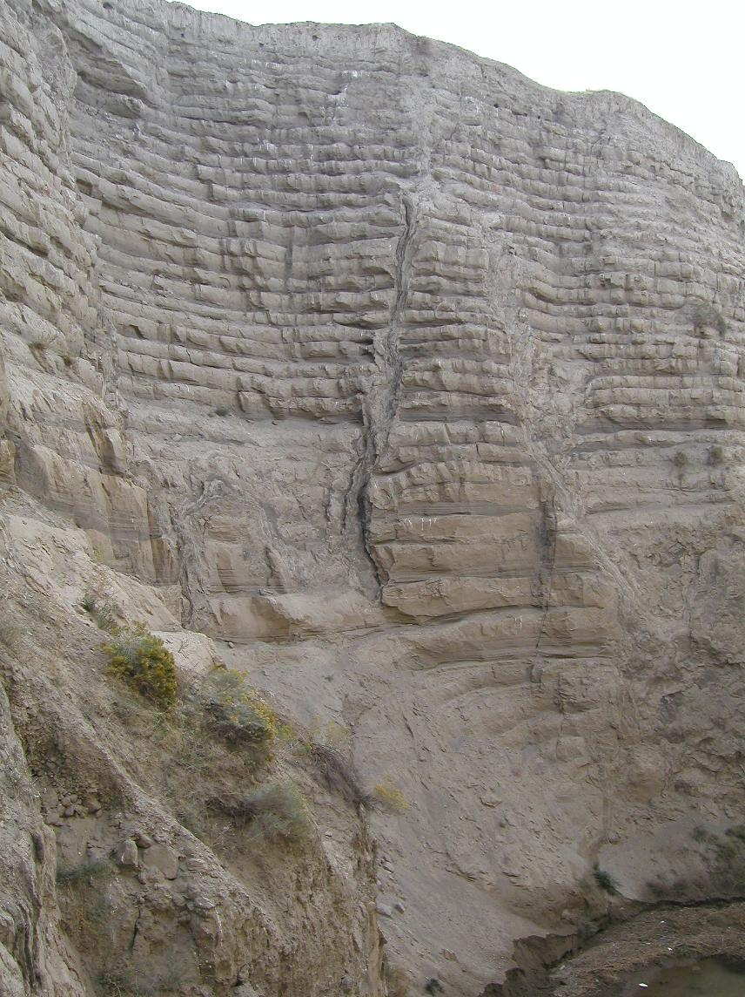
However, because of a great many layers of earth deposits in Washington State, this is supposed to have happened 10 times, 20 times, 45 times, even 90 times. There is a severe problem with claiming that this happened many times, over a period of about 2,000 years. Glaciers do not form 2,000 foot high walls. They hug the ground and occupy the lowest terrain. Possibly, the glacier could slowly advance; be melted down to a high wall while the Missoula Lake refills, then the same dam break occurs. But the time allowed for each of these sequences is only about 55 years. Much too little time. Furthermore, there is no logical reason why the glacier would retreat and advance many times over in a span of 2,000 years. Finally, the deposit layers in the above photograph are very uniform. What chance is there that a “local” flood would repeat its behavior precisely the same a great many times?
There is another plausible cause for a flood that repeats many times. In 2012 astronomers confirmed that there are “wandering” planets that are not held within a solar system. They also announced that these planets are very common. If actual planets have a nuclear core that is not penetrated by gravitons, then their presumed mass, based on their gravitational field, will not be the entire mass of the planet. If this is the case, then these planets would be highly resistant to having their course or orbit being changed.
If such a planet were to enter our solar system and pass within a few million miles of Earth, both planets would mutually block the gravitational flux between them – especially because of nuclear cores. The gravitational upset would last about two months as the planets passed each other. Since Earth rotates once every 24 hours, this would set up a planet wide tidal wave. How high the wave would be is an open question. However, in the direction of travel, it would be at least 600 miles long. The surge would wash over the whole Earth with the least effect at the poles and the greatest effect near the equator. With the corresponding rise in sea level of 350 to 400 feet, human civilization would be almost entirely destroyed. There are many man made structures throughout the world that are under sea level.
Is there evidence that human history indicates there was an awareness and response to a planet passing near Earth and thus causing a worldwide tidal wave? Yes. This was discussed in the chapter “THE GREAT PYRAMID”.

EXTRATERRESTRIALS
Due to the production of plutonium and probable space travel, can we attribute these ancient achievements to extraterrestrials?
Maybe.
However, with a worldwide flood having destroyed civilization on Earth and many artificial structures now being under sea level, we have lost knowledge of how advanced human civilization was before the flood. So, attributing these abilities to extraterrestrials is not needed.
There is no apparent planet within our solar system where such extraterrestrials would have evolved and established a high technology civilization. Possibly Mars but evidence is lacking.
Using plutonium as an igniter and polydeuterium as a primary fuel does not give the capacity to travel from another star to our solar system – unless these “aliens” had extraordinary long lives of many thousands of years. Even then, it would be a very dubious undertaking on their part.

FORMULATION OF POLYDEUTERIUM ROD
The figure below is a process diagram for formulating polydeuterium as a fuel for an airborne or space born ship.
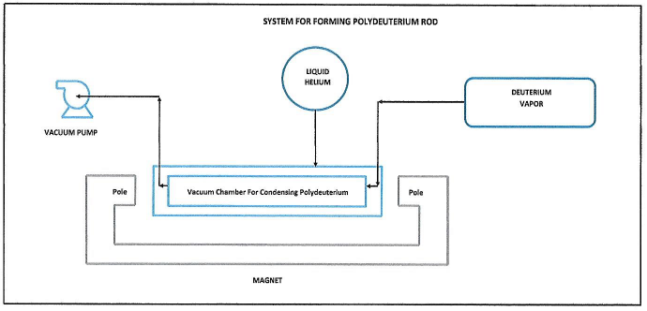
The process includes the following steps:
- The vacuum chamber would be brought to vacuum with a vacuum pump. It would be ideal if the chamber was kept hot by passing steam to the surrounding jacket.
- After the vacuum step is complete, the vacuum chamber would be brought to as close to absolute zero as is possible by passing liquid helium to the surrounding jacket and allowing vaporization of helium to lower the temperature.
- The surrounding magnet would be energized so as to create a linear magnetic field along the length of the vacuum chamber.
- Deuterium vapor would be released into the vacuum chamber and withdrawn by the vacuum pump until measurement indicates that only deuterium vapor is exiting the vacuum pump.
- Deuterium vapor would be bled into the vacuum chamber and allowed to solidify.
- The final result would be a solid polydeuterium rod.
ROCKET ENGINE
- Nuclear rocket engines were designed, built, and tested in the 1960’s. They were successful and produced about twice the thrust of a chemical rocket engine. This was done with U-235 heating liquid hydrogen as an exhaust gas. About 2.5% of the energy in the U-235 nucleus is released. There is considerable radioactive waste.
- Using the polydeuterium rod described in the previous chapter, a very small amount of Pu-239 is used as an igniter of the polydeuterium, through the release of neutrons. When polydeuterium undergoes nuclear fission, 100% of the energy within the nuclei is released. Atomic hydrogen is the end result of polydeuterium being split. The released hydrogen vapor, at extremely high temperature, is the rocket exhaust gas. No radioactive nuclei come out of the rocket in the exhaust gas.
- Below is a very simple process diagram of using polydeuterium as the rocket fuel. This type of propulsion would enable humans to travel throughout our solar system – with fuel to spare. However, travel to another star would not be possible because the spaceship velocity obtained by this engine would be substantially less than the speed of light. Consequently, such a trip would take much longer than a human lifespan.

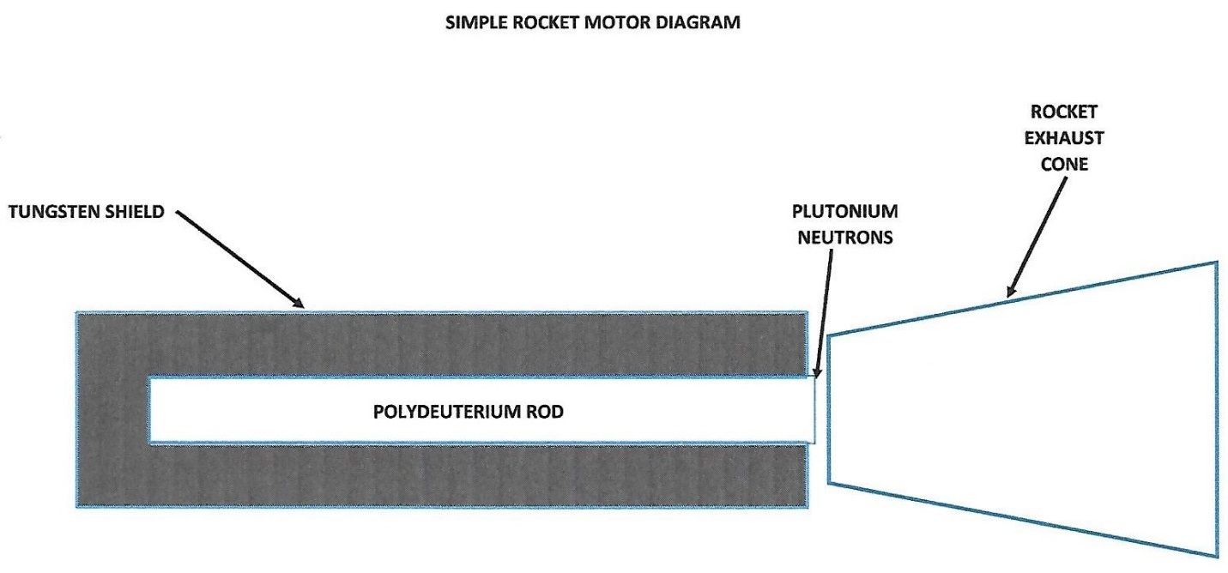

ENERGY REPLACEMENT
Using the fission of polydeuterium as a major energy source would have a profound effect on other energy sources. This fission process would be useful in large aircraft and space craft. It would be effective in ships and perhaps train engines. It would become the sole source of energy for power plants.
Coal would be reduced to being a technical curiosity. Petroleum would no longer be wasted as simply a fuel to be burned. Instead, it would be converted over to making a great many useful products. Natural gas and propane would remain as fuels for individual homes and so on, because they can be readily dispersed to all small users.
The use of hydroelectric power, wind energy and solar energy would be greatly reduced because of their questionable economic value in comparison to the energy produced by fissioning deuterium.

SUMMARY
This is a recapitulation of the major premises and conclusions of this paper:
- Existence exists. Therefore the universe is infinite and eternal.
- Tom Van Flandern’s “Physics Has Its Principles” is the conceptual foundation for additional conclusions.
- Fundamental particles are permanent and totally passive. They do not have a lifespan.
- All physical interaction is by collisions.
- Gravity is actually a universal flux of extremely small but high velocity particles. So, gravity is a push, not an attractive force.
- Light, a visible range of the electromagnetic spectrum is only a momentum wave within a light carrying medium, called the Elysium. Its particles are called elysons.
- The atom has a nucleus made of protons; it constitutes a major fraction of the volume of the atom.
- There is no such thing as orbiting electrons.
- The proton is hypothesized to be a hollow pyramid.
- The graviton flux pushes the light carrying medium particles up against the proton, where both condensation and vaporization of the elysons can occur because of the asymmetric shape of the proton.
- The hydrogen molecule consists of two protons, attached tip to tip. The condensed elysons act as a “glue” to keep the tip to tip mating stable.
- Deuterium consists of two protons mated base to base. This creates a hollow space inside containing liquid Elysium. The Elysium is brought to extreme temperature because a few gravitons are captured within the hollow chamber. This is the source of the extreme energy contained within a nucleus.
- The only true nuclear fusion reaction is the mating of the two protons to make deuterium. Thereafter, deuterium atoms polymerize into vast nuclear spheres.
- The hydrogen bomb is entirely a fission bomb.
- The beginning content of a nebula that will contract to a solar system requires only protons and elysons.
- Planets are initially formed as monstrous polydeuterium spheres.
- Radioactive breakdown at the surface of these spheres creates all the atomic elements and their isotopes.
- The Sun is largely composed of liquid Elysium. The bombardment of this liquid Sun by the gravitational flux is the sole source of heat and light emanating from the Sun.
- The radioactive breakdown of a planet’s nuclear core results in normal matter with high angular momentum. This will result in rings such as Saturn has, if some of the material can remain “frozen”. Moons may be created by the close passage of another planetary body.
- The nuclear structure of deuterium through carbon are shown graphically. Since the nucleus contains only protons, mated base to base or side to side, assigning a count of protons being equal to the proposed number of electrons is nonsense.
- Magnetism is actually the flux of gravitons becoming a bidirectional flow, caused by the crystal (molecular) structure of such a material as iron.
- A magnetic beam may be the means of communication between stars because it would travel at 20 billion times the speed of light.
- Electricity is simply the flow of liquid elysons over the molecular surface of a material such as copper.
- Analysis of ancient history shows that the Great Pyramid was a nuclear plutonium mill.
- The other two pyramids at Giza, Egypt were functional steps of the plutonium purifying and shaping process.
- Ancient history provides strong evidence that the three pyramids at Giza, Eqypt, were built because of the anticipated arrival of a rogue planet passing near the Earth. Such a close passage would cause a worldwide tidal wave that would destroy conventional human civilization. The pyramids were designed to survive such a tidal wave and they would be the primary source of energy for humans after the tidal wave ended and humans returned to Earth.
- The existence of extraterrestrials involved with this pyramid building and the re-establishment of civilization on Earth is a possibility but not necessarily true.
- Examination of the plutonium production at the Great Pyramid was so small that plutonium could not be a primary fuel. Deuterium would be the primary fuel that would undergo fissioning, started by the plutonium acting as an igniter of the fuel through its emission of neutrons.
- A process for formulating polydeuterium rods and a simple rocket engine using the polydeuterium rods as fuel is briefly described.
- The use of polydeuterium as a fission energy source would have a profound economic effect on the use of other, less efficient energy sources.
BIBLIOGRAPHY

Pushing Gravity: New Perspectives on Le Sage’s Theory of Gravitation, C. Roy Keys Inc., Apeiron, Montreal Quebec, 2002, edited by Matthew R. Edwards

Dark Missing, Missing Planets & New Comets, North Atlantic Books, Berkeley California, 1993, Astronomer Tom Van Flandern

Uncommon Knowledge, AuthorHouse, Bloomington Indiana, 2010, Al McDowell

The Solar Photosphere: Evidence for Condensed Matter, Meta Research Bulletin, June 16, 2006, Pierre-Marie Robitaille, Ph. D., Chemical Physics Program, The Ohio State University, Columbus Ohio

The Phoenix Solution (Secrets of a Lost Civilization, Hodder & Stoughton, London England, 1998, Alan F. Alford

